Journal of Integrated Scientific Research (JISR)

https://jisrjournal.com/

Explainable Artificial Intelligence for Trustworthy Decision-Making in Intelligent Computing Systems
Suresh Babu Narra
IEEE Senior Member
Solutions Architect – AI, Machine Learning & Generative AI
Cincinnati, Ohio, USA
Email: narra.sureshbabu@gmail.com
Abstract
Intelligent computing systems increasingly make or support high-stakes decisions, and regulations now require that such decisions be transparent and open to human oversight. Explainable AI (XAI) methods are widely used to meet these demands, yet they are rarely evaluated quantitatively, and different methods often disagree. This paper proposes a trustworthy decision framework that couples predictive models with explanation quality assurance, calibrated confidence, and actionable recourse, and evaluates it on three real benchmark datasets (breast-cancer diagnosis, diabetes progression, handwritten digits) and a synthetic dataset with known ground truth. Five local explanation methods (SHAP, LIME, Integrated Gradients, Gradient×Input, and Occlusion) are implemented from first principles and assessed for correctness, faithfulness, stability, agreement, and sanity, across glass-box and black-box models. Interpretable models match black-box accuracy on the clinical datasets (logistic regression AUC 0.840 vs. 0.809 for the best black box on diabetes). Shapley values recover the true feature relevance most accurately (top-3 agreement 0.85 for gradient boosting), whereas gradient-based methods collapse on tree ensembles and perform no better than random deletion. Methods agree on only 41% of their top-5 features for gradient boosting. Signed attribution maps pass a model-randomization sanity check, whereas absolute maps largely track input intensity. Explanations exposed an injected shortcut artefact as the top-ranked feature, and removing it raised deployment AUC from 0.951 to 0.978. Actionability-constrained counterfactuals required changes to 2.4 features on average, and calibrated selective prediction raised accuracy on diabetes from 71.3% to 76.6% at 80% coverage. The paper concludes with evidence-based guidelines for deploying XAI in trustworthy decision systems.

Keywords – Explainable artificial intelligence (XAI), trustworthy AI, interpretability, Shapley values, LIME, integrated gradients, counterfactual explanations, faithfulness, calibration, selective prediction, shortcut learning.

1. Introduction
Machine-learning (ML) models now support decisions in medicine, finance, public services, and industrial automation. Their accuracy often comes from complex, opaque functions, ensembles of thousands of trees or deep networks with millions of parameters, whose reasoning cannot be inspected directly. Opacity undermines trust, hides errors and biases, and conflicts with emerging legal requirements: the EU General Data Protection Regulation restricts solely automated decisions with significant effects (Art. 22) [1], the EU Artificial Intelligence Act requires high-risk systems to be transparent to deployers and subject to human oversight (Arts. 13–14) [2], and the NIST AI Risk Management Framework lists explainability and interpretability among the characteristics of trustworthy AI [3].
Explainable AI (XAI) seeks to make model behaviour understandable to humans [4]–[7]. Post-hoc methods such as LIME [8], SHAP [9], and Integrated Gradients [10] attribute a prediction to input features, while counterfactual explanations describe how an input would need to change to obtain a different outcome [11]. Rudin argues that interpretable models should be preferred over explained black boxes in high-stakes settings [12]. However, explanations are themselves model outputs that can be unfaithful, unstable, or manipulable [13]–[16], and practitioners face a disagreement problem when methods produce conflicting explanations [17]. Trustworthy decision-making therefore requires evaluating explanations, not merely producing them.
This paper makes the following contributions:
- A framework for trustworthy decision-making that integrates model choice, explanation, explanation quality assurance, calibrated confidence with a reject option, and recourse under human oversight (Fig. 1).
- A multi-criteria benchmark of five explanation methods, implemented from first principles, for correctness against ground truth, faithfulness, stability, agreement, and sanity, on three real datasets and one synthetic dataset.
- An empirical test of the accuracy–interpretability trade-off across six model families.
- Three decision-oriented case studies: detection of shortcut learning, actionable counterfactual recourse, and calibrated selective prediction.
- Evidence-based guidelines and open, reproducible code.
Section 2 reviews related work. Section 3 describes the framework and methods, Section 4 presents results, Section 5 discusses implications and limitations, and Section 6 concludes.

2. Background and Related Work

2.1 Taxonomy of XAI Methods
XAI methods are commonly classified as intrinsic (interpretable by design) or post hoc, as local (explaining one decision) or global (explaining overall behaviour), and as model-agnostic or model-specific [5], [6]. Interpretable models include linear and logistic regression, shallow decision trees, and generalized additive models (GAMs) [18], [19]. Post-hoc attribution methods include perturbation-based approaches (LIME [8], Shapley sampling [20], occlusion [21]) and gradient-based approaches (Gradient×Input [22], Integrated Gradients [10]). SHAP unifies several attribution methods under the Shapley value from cooperative game theory [9], [23]. Table 1 summarizes the methods studied here.
TABLE 1: Explanation methods evaluated in this study
Method | Type | Scope | Agnostic | Key property | Ref.
SHAP (sampling) | Perturbation | Local, global | Yes | Efficiency, symmetry axioms | [9], [20]
LIME | Surrogate | Local | Yes | Local linear fidelity | [8]
Integrated Gradients | Gradient | Local | No* | Completeness, sensitivity | [10]
Gradient×Input | Gradient | Local | No* | First-order Taylor | [22]
Occlusion | Perturbation | Local | Yes | Single-feature ablation | [21]
Counterfactual (GS) | Example | Local | Yes | Actionable recourse | [11], [24]
LR / GAM / DT | Intrinsic | Global | — | Transparent by design | [12], [18]
*Requires a differentiable model; numerical gradients are used here so that the methods can be applied to any model and their failure on piecewise-constant models can be observed.

2.2 Evaluating Explanations
Doshi-Velez and Kim distinguished application-grounded, human-grounded, and functionally grounded evaluation [4]. Functional metrics include faithfulness, measured by perturbation curves such as deletion and AOPC [13] or by retraining (ROAR) [25]; robustness, measured as the sensitivity of explanations to small input changes [14]; and sanity checks, which test whether explanations change when the model is randomized [15]. Slack et al. showed that LIME and SHAP can be fooled by adversarially designed models [16], and Krishna et al. documented widespread disagreement among methods [17]. Ground-truth evaluation on synthetic data allows explanation correctness to be measured directly.

2.3 Explanations, Trust, and Decision Support
Trustworthy decision support also needs well-calibrated confidence [26] so that humans know when to rely on the model, a reject option that defers uncertain cases to experts [27], and recourse that tells affected individuals what they could change [11], [24]. Explanations help detect shortcut learning, in which models exploit spurious correlations [28], [29]. Explanations should also be contrastive and selective to serve human users [30]. The DARPA XAI program has emphasized pairing explanation with appropriate trust calibration [7].

3. Framework and Methodology

3.1 Trustworthy Decision Framework
Fig. 1 shows the proposed framework. Data are audited for shifts and artefacts. Models are selected on the accuracy–interpretability frontier (experiment E1). Each prediction is accompanied by a local explanation, and the explainer is validated by an explanation quality-assurance stage that tests correctness, faithfulness, stability, agreement, and sanity (E2–E7). The decision stage combines calibrated probabilities with a reject option and counterfactual recourse (E9–E10), and a human decision-maker retains oversight and provides feedback. Shortcut detection (E8) closes the loop back to the data.

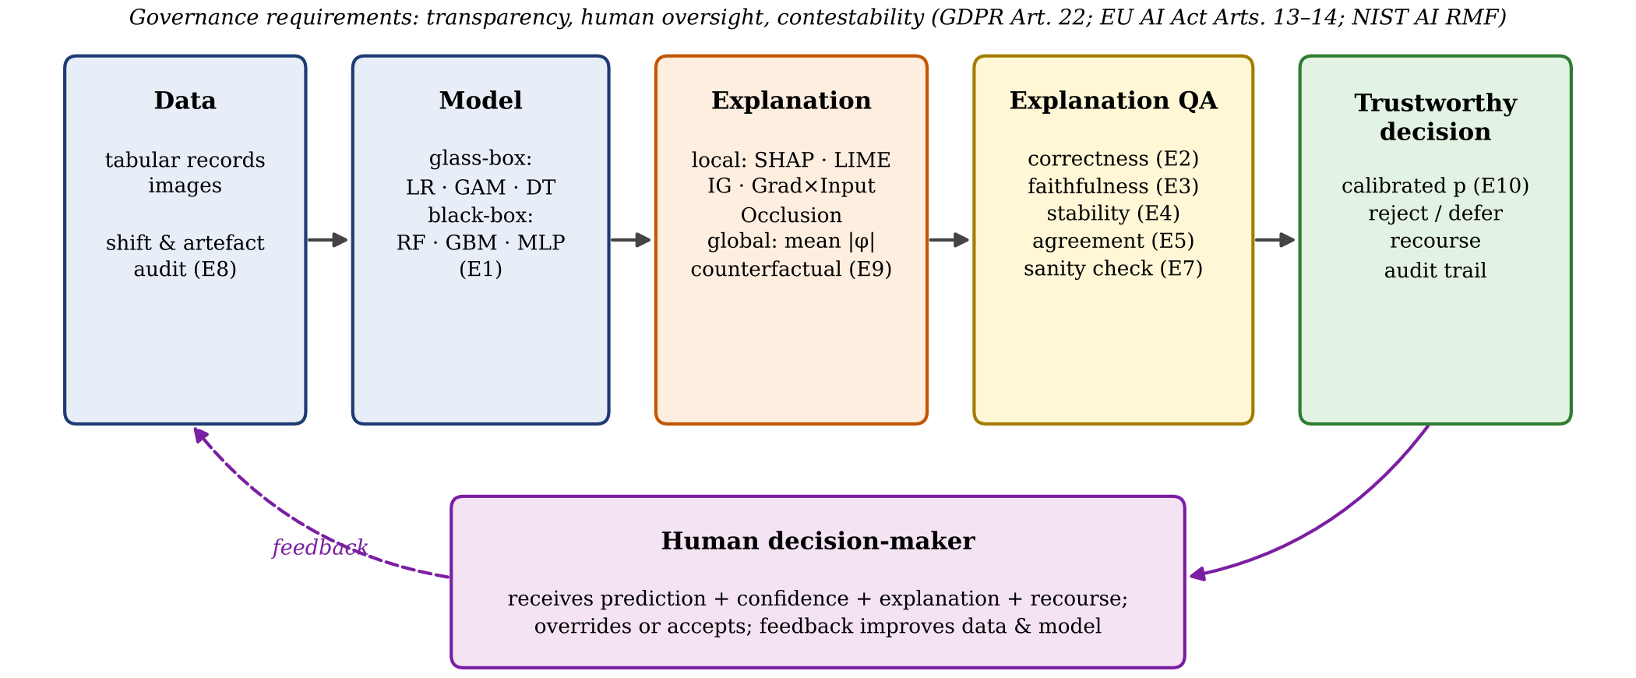
Fig. 1. Framework for trustworthy decision-making with XAI. Labels E1–E10 refer to the experiments reported in Section IV.

3.2 Datasets and Models
Table II lists the datasets. Breast Cancer Wisconsin (BC) and Diabetes (DIAB) are real clinical datasets with decision-relevant features; DIAB is binarized at the median disease progression. Optical digits (DIG) provides image-like inputs for pixel attributions. The synthetic dataset (SYN) has twelve Gaussian features, of which only x₁–x₅ are relevant: logit(p) = 2x₁ − 1.5x₂ + (x₃² − 1) + 1.5x₄x₅. Feature x₆ is an irrelevant distractor correlated with x₁ (ρ = 0.8). Because the generating function is known, the true interventional Shapley values are available in closed form, for example φ₄ = φ₅ = 0.75x₄x₅. Six models are compared: three glass-box models (logistic regression (LR); a GAM built from cubic splines with logistic regression; a decision tree (DT) of depth 4) and three black-box models (random forest (RF), histogram gradient boosting (HistGB), and a two-layer multilayer perceptron (MLP)), all implemented in scikit-learn on standardized inputs.
TABLE 2: Datasets
Dataset | Domain | n | d | Classes | Positive rate
BC | Tumour diagnosis | 569 | 30 | 2 | 37.3%
DIAB | Disease progression | 442 | 10 | 2 | 50.0%
DIG | Handwritten digits | 1797 | 64 | 10 | —
SYN | Ground-truth benchmark | 4000 | 12 | 2 | 49.5%

3.3 Explanation Methods
For a model output f (the predicted probability of the class of interest) and an instance x, interventional Shapley values average the marginal contribution of feature j over all coalitions S,
φ_{j} = Σ_{S⊆F∖j} [|S|!(d−|S|−1)!/d!] [v(S∪{j}) − v(S)] (1)
with v(S) = E_{b}[f(x_{S}, b_{S̄})] over a background sample of 32 training points. Eq. (1) is estimated by 32 antithetic random permutations [20], which preserves efficiency exactly (Σφ_{j} = f(x) − Ef). LIME fits a weighted ridge surrogate on 1,000 samples drawn from the training distribution,
β̂ = argmin_{β} Σ_{z} π_{x}(z)(f(z) − β^{T}z)² + λ‖β‖² (2)
with proximity kernel π_{x}(z) = exp(−‖z − x‖²/w²), w = 0.75√d, and attribution φ_{j} = β̂_{j} x_{j}. Integrated Gradients integrates the gradient along the path from the zero (mean) baseline,
IG_{j}(x) = x_{j} ∫₀¹ ∂f(αx)/∂x_{j} dα (3)
approximated with 32 midpoint steps. Gradient×Input uses φ_{j} = x_{j} ∂f/∂x_{j}, and Occlusion uses φ_{j} = f(x) − f(x_{j←0}). Gradients are computed by central differences so that every method can be applied to every model. All five methods were verified against closed-form attributions of linear and pure-interaction functions (maximum error below 10⁻¹⁵).

3.4 Explanation-Quality Metrics
Correctness (SYN) is measured as the top-3 agreement between |φ| and the true |φ*|, the Spearman correlation across features, and the attribution mass assigned to irrelevant features. Faithfulness is measured by deletion and insertion curves: features are set to the baseline (deletion), or restored from it (insertion), in decreasing order of their attribution toward the predicted class c, giving
AOPC = (1/(d+1)) Σ_{k=0}^{d} [p_{c}(x) − p_{c}(x^{(k)})] (4)
and the insertion AUC, each compared with a random feature order. Stability is the relative change
S(x) = E_{δ}‖φ(x) − φ(x+δ)‖ / ‖φ(x)‖ (5)
under Gaussian input noise δ ~ N(0, 0.05²I) that does not change the prediction, together with run-to-run variability across random seeds for the stochastic methods. Agreement between methods a and b is the top-k feature agreement,
FA@k = |top_{k}(φ^a) ∩ top_{k}(φ^b)| / k (6)
with k = 5, plus the Spearman correlation of |φ|. The sanity check compares explanations of a trained MLP with those of the same network after its weights are randomly permuted, both for absolute and for signed maps, over the 61 non-constant pixels of DIG.

3.5 Decision-Support Experiments
Shortcut detection (E8): a synthetic "site artefact" feature equal to the label with probability 0.95 (plus noise) is added to BC training and validation data and made uninformative at deployment, mimicking spurious correlations such as scanner or hospital identifiers. Counterfactual recourse (E9): for DIAB patients predicted to have high progression, counterfactuals solve
x′ = argmin ‖x′ − x‖₁ s.t. f(x′) < 0.5, x′_{I} = x_{I} (7)
using growing-spheres search followed by greedy sparsification, with age and sex as immutable features I (GS-actionable). These are compared with an unconstrained variant (GS) and the nearest unlike neighbour (NUN) from the training data. Metrics are validity, actionability, the number of changed features, L1 distance, implausibility (distance to the nearest training point of the target class relative to the median nearest-neighbour distance), and run time. Calibrated selective prediction (E10): out-of-fold probabilities from five-fold cross-validation, raw and with Platt scaling, are evaluated by the expected calibration error
ECE = Σ_{m} (|B_{m}|/n) |acc(B_{m}) − conf(B_{m})| (8)
over 15 confidence bins, and by risk–coverage curves, in which the least confident cases are deferred to a human.

3.6 Protocol and Implementation
Accuracy is estimated by 5-fold cross-validation repeated three times. Explanation experiments use a stratified 70/30 split with 40 randomly selected test instances per dataset–model pair (20 for stability). All methods and metrics are implemented in Python with NumPy and scikit-learn, without third-party XAI libraries, so every step is transparent. The code and all result files are provided as supplementary material.

4. Results

4.1 Accuracy–Interpretability Trade-off (E1)
Table 3 and Fig. 2 show that the expected trade-off holds only partly. On the clinical datasets, glass-box models are as accurate as black boxes: on BC, LR reaches AUC 0.995 against 0.994 for HistGB, and on DIAB, LR (0.840) and the GAM (0.837) outperform every black box (best RF, 0.809) with two to three orders of magnitude fewer parameters. This supports Rudin's argument for interpretable models in high-stakes tabular settings. A trade-off appears only where the signal is genuinely nonlinear: on SYN, which contains a quadratic term and an interaction, HistGB (0.894) outperforms LR (0.837), while the GAM recovers most of the gap (0.876). Shallow trees are the least accurate on every dataset.
TABLE 3: Cross-validated ROC AUC (mean ± s.d., 3×5-fold)
Model | BC | DIAB | DIG | SYN | Params (BC)
LR (G) | 0.995 ± 0.005 | 0.840 ± 0.040 | 0.999 ± 0.000 | 0.837 ± 0.007 | 31
GAM (G) | 0.994 ± 0.005 | 0.837 ± 0.036 | 0.999 ± 0.000 | 0.876 ± 0.007 | 211
DT (G) | 0.923 ± 0.038 | 0.753 ± 0.054 | 0.867 ± 0.012 | 0.814 ± 0.010 | 23
RF (B) | 0.991 ± 0.008 | 0.809 ± 0.033 | 0.999 ± 0.000 | 0.880 ± 0.005 | 12,624
HistGB (B) | 0.994 ± 0.004 | 0.778 ± 0.036 | 0.999 ± 0.000 | 0.894 ± 0.006 | 12,858
MLP (B) | 0.994 ± 0.005 | 0.783 ± 0.028 | 0.999 ± 0.002 | 0.859 ± 0.010 | 6,209
(G): glass-box; (B): black-box. DIG: macro one-vs-rest AUC. Params: coefficients, tree nodes, or network weights for the model fitted to BC.

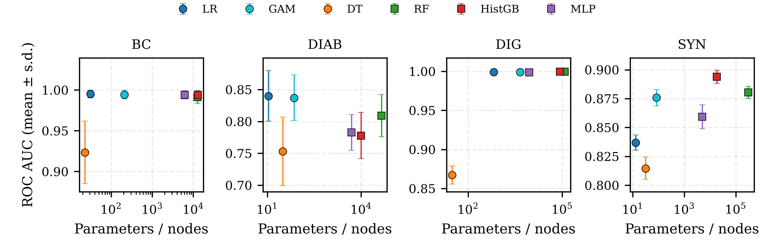
Fig. 2. Accuracy versus model complexity (log scale). Circles: glass-box models; squares: black-box models. Error bars: s.d. over 15 cross-validation folds.

4.2 Explanation Correctness (E2)
Table 4 and Fig. 3 evaluate the methods against ground truth. For the nonlinear models, SHAP is the most correct method: top-3 agreement of 0.85 (HistGB) and 0.75 (MLP), with the highest rank correlation. LIME is second (0.73 and 0.71) and places the least mass on irrelevant features, because its global linear surrogate suppresses noise. Gradient-based methods fail on HistGB: Gradient×Input assigns 48% of its attribution to irrelevant features, since numerical gradients of a piecewise-constant ensemble are zero almost everywhere and spike at split thresholds. IG and Occlusion also struggle with the MLP (agreement ≤ 0.45) because single-feature ablation misses the x₄x₅ interaction and the curvature of x₃². For LR, all methods coincide (agreement 0.60). Their shared ceiling reflects the model's inability to represent the true function, not a failure of the explainers. This shows that an explanation can only be as correct as the model it explains. No method attributed substantial mass to the correlated distractor x₆ (≤ 4.9%).
TABLE 4: Explanation correctness on SYN (40 instances)
Model | Method | Top-3 agr. | Spearman | Irrel. mass (%) | Distractor (%)
HistGB | SHAP | 0.85 | 0.64 | 13.9 | 2.1
 | LIME | 0.73 | 0.54 | 8.4 | 1.0
 | IG | 0.66 | 0.42 | 28.0 | 4.9
 | Grad×Input | 0.39 | 0.10 | 48.0 | 4.6
 | Occlusion | 0.65 | 0.46 | 16.7 | 3.2
MLP | SHAP | 0.75 | 0.62 | 22.8 | 3.4
 | LIME | 0.71 | 0.55 | 14.9 | 1.7
 | IG | 0.43 | 0.20 | 48.8 | 4.7
 | Grad×Input | 0.42 | 0.29 | 40.2 | 4.1
 | Occlusion | 0.45 | 0.29 | 24.3 | 3.1
LR | SHAP | 0.60 | 0.58 | 6.7 | 2.3
 | LIME | 0.60 | 0.55 | 7.9 | 2.3
 | IG | 0.60 | 0.58 | 7.6 | 2.3
 | Grad×Input | 0.60 | 0.58 | 7.6 | 2.3
 | Occlusion | 0.60 | 0.58 | 6.5 | 2.0
Test AUC: HistGB 0.908, MLP 0.877, LR 0.855. Distractor: share of |φ| assigned to x₆.

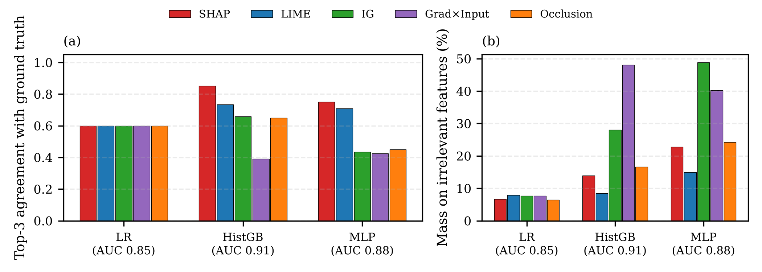
Fig. 3. Correctness against ground-truth Shapley values on SYN: (a) top-3 feature agreement; (b) share of attribution mass assigned to the seven irrelevant features.

4.3 Faithfulness (E3)
Fig. 4 and Table V report deletion and insertion behaviour on the real datasets. For the MLP, all five methods are highly faithful: removing the top-ranked features collapses the predicted-class probability far faster than random removal (AOPC 0.50–0.60 vs. 0.09 on BC). For HistGB, Gradient×Input is no better than random (AOPC 0.11 vs. 0.13 on BC; 0.21 vs. 0.21 on DIAB). IG remains faithful because its path integral crosses split thresholds. Occlusion scores highly on deletion, partly by construction, since it measures exactly the single-feature removal that the metric applies. Among model-agnostic methods, SHAP and LIME are consistently in the top group, with SHAP achieving 2.7× the random AOPC on DIAB-MLP.
TABLE 5: Faithfulness: deletion AOPC (higher is better)
Dataset · model | SHAP | LIME | IG | G×I | Occl. | Random
BC · HistGB | 0.59 | 0.63 | 0.57 | 0.11 | 0.60 | 0.13
BC · MLP | 0.58 | 0.60 | 0.60 | 0.50 | 0.51 | 0.09
DIAB · HistGB | 0.50 | 0.46 | 0.45 | 0.21 | 0.51 | 0.21
DIAB · MLP | 0.60 | 0.58 | 0.54 | 0.56 | 0.57 | 0.22
Mean over 40 test instances; deletion replaces features with the training mean in order of attribution. G×I: Gradient×Input.

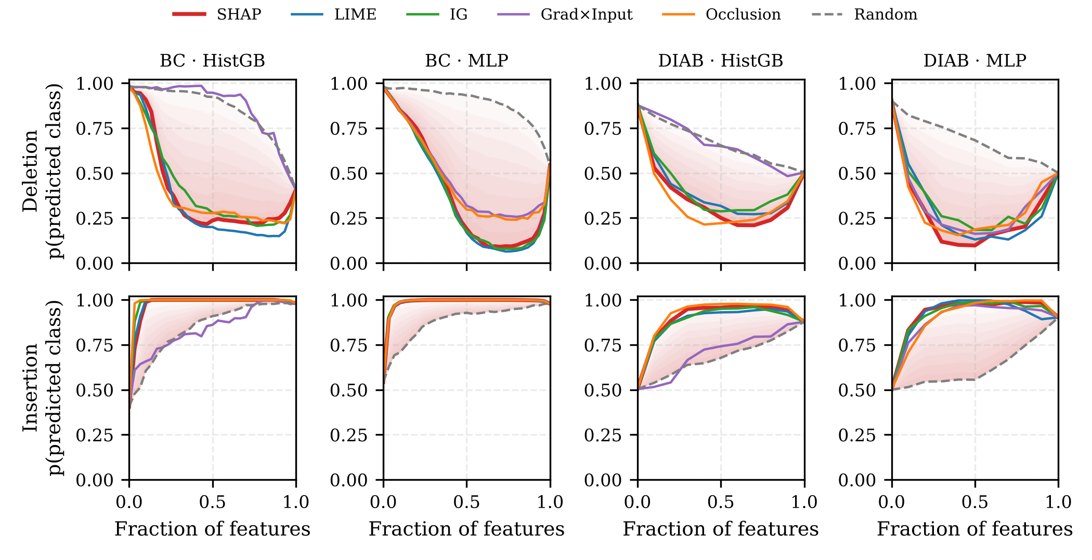
Fig. 4. Deletion (top) and insertion (bottom) curves of the predicted-class probability. Shading: area between SHAP and the random-order baseline.

4.4 Stability and Cost (E4)
Table 6 and Fig. 5 show that SHAP and LIME are the most stable methods under small input perturbations (median relative change 0.04–0.13 and 0.05–0.07 across the four dataset–model pairs). Occlusion (0.19–0.31) and IG (0.07–0.65) are less stable, especially on HistGB, where the explanation changes as a perturbation crosses a split threshold, and Gradient×Input on HistGB is unstable, since its near-zero attributions flip whenever a threshold is crossed. The price of SHAP and LIME's sampling is seed variability: with 32 permutations or 1,000 samples, re-running the explainer changes the attribution vector by about 18% (SHAP) and 19% (LIME). Such variability is invisible to users unless it is reported, and it argues for larger sample budgets or confidence intervals on attributions in audited decisions. SHAP is also the most expensive method (87 ms per explanation vs. 5–13 ms for the others), although all are fast enough for interactive use.
TABLE 6: Stability (median relative change) and cost
Method | BC·GB | BC·MLP | DIAB·GB | DIAB·MLP | Seed var. | ms / expl.
SHAP | 0.07 | 0.04 | 0.13 | 0.08 | 0.18 | 87.3
LIME | 0.07 | 0.06 | 0.05 | 0.06 | 0.19 | 13.2
IG | 0.37 | 0.07 | 0.65 | 0.13 | 0 | 13.0
Grad×Input | 5.40 | 0.17 | >10 | 0.44 | 0 | 7.4
Occlusion | 0.30 | 0.19 | 0.23 | 0.31 | 0 | 5.1
Input noise σ = 0.05 s.d.; GB: HistGB. Seed var.: mean relative change between two runs with different random seeds (deterministic methods: 0).

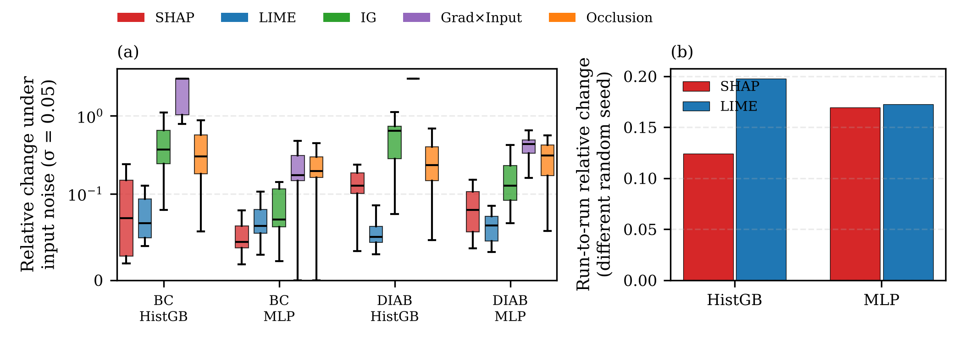
Fig. 5. Stability: (a) relative change of attributions under small input noise (symmetric-log scale); (b) run-to-run variability of the sampling-based explainers.

4.5 Disagreement Between Methods (E5)
Fig. 6 confirms the disagreement problem. For HistGB on BC, the methods share on average only 41% of their top-5 features (56% excluding Gradient×Input). Agreement is higher for the smooth MLP (64%), where gradient and perturbation methods converge. The most concordant pair is SHAP–LIME for HistGB (0.69) and Grad×Input–Occlusion for the MLP (0.86); the latter pair agrees because both reduce to single-feature effects on a smooth model. A practitioner who chose an explainer arbitrarily could thus present different "reasons" for the same decision, a direct threat to contestability.

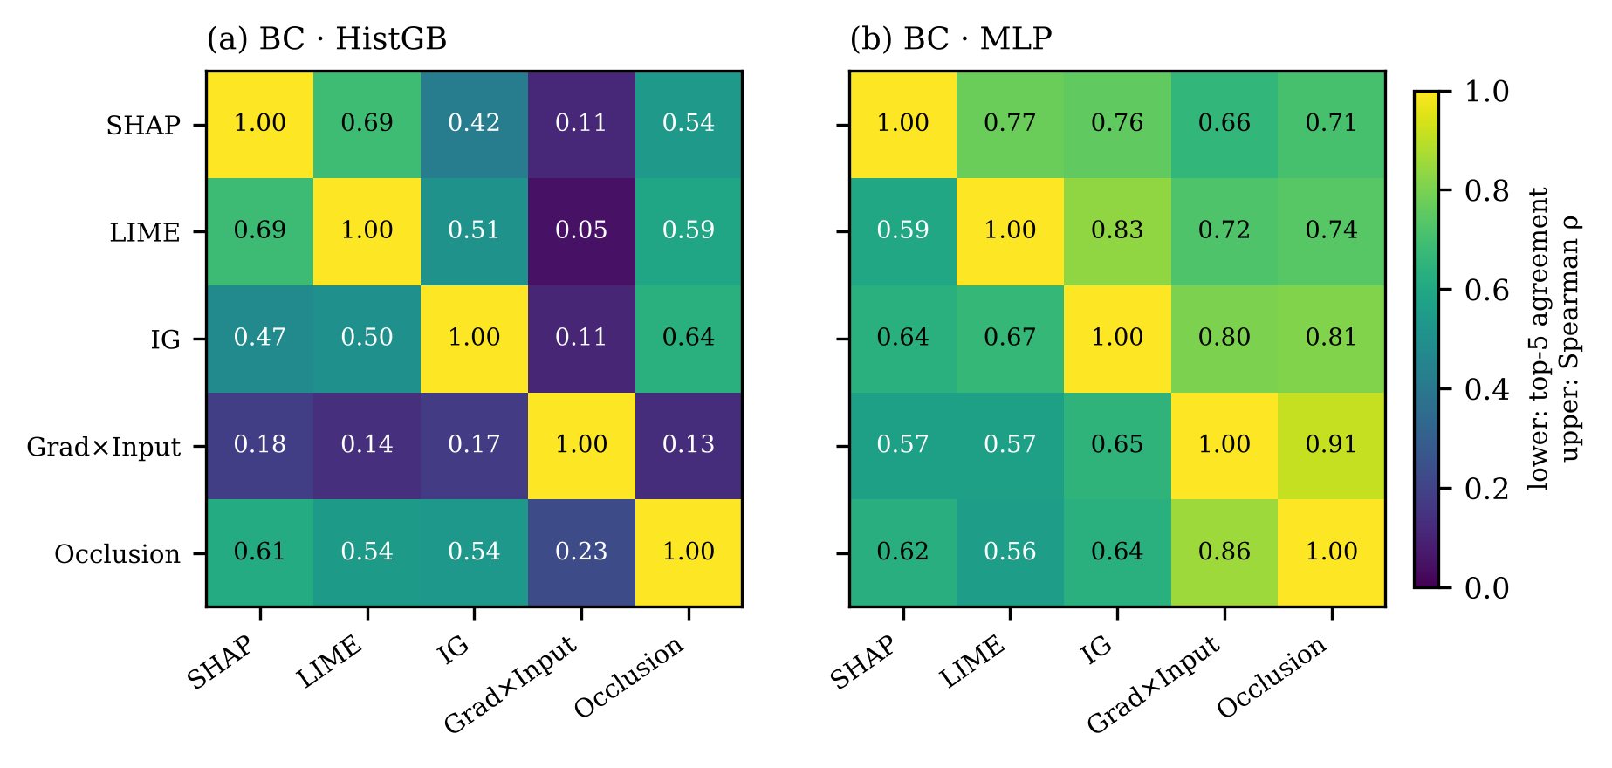
Fig. 6. Pairwise agreement of explanation methods on BC (40 instances): lower triangle, top-5 feature agreement; upper triangle, Spearman rank correlation of |φ|.

4.6 Global Explanation (E6)
Aggregating local Shapley values over all 171 BC test cases yields a global explanation (Fig. 7). The five most influential features (worst perimeter, worst concave points, mean concave points, and two other size and shape descriptors) carry 61% of the total attribution. The beeswarm shows monotone, clinically plausible effects: larger and more irregular nuclei increase the predicted probability of malignancy, consistent with the cytological rationale of the original study. Such plausibility checks are a practical way for domain experts to validate a model before deployment.

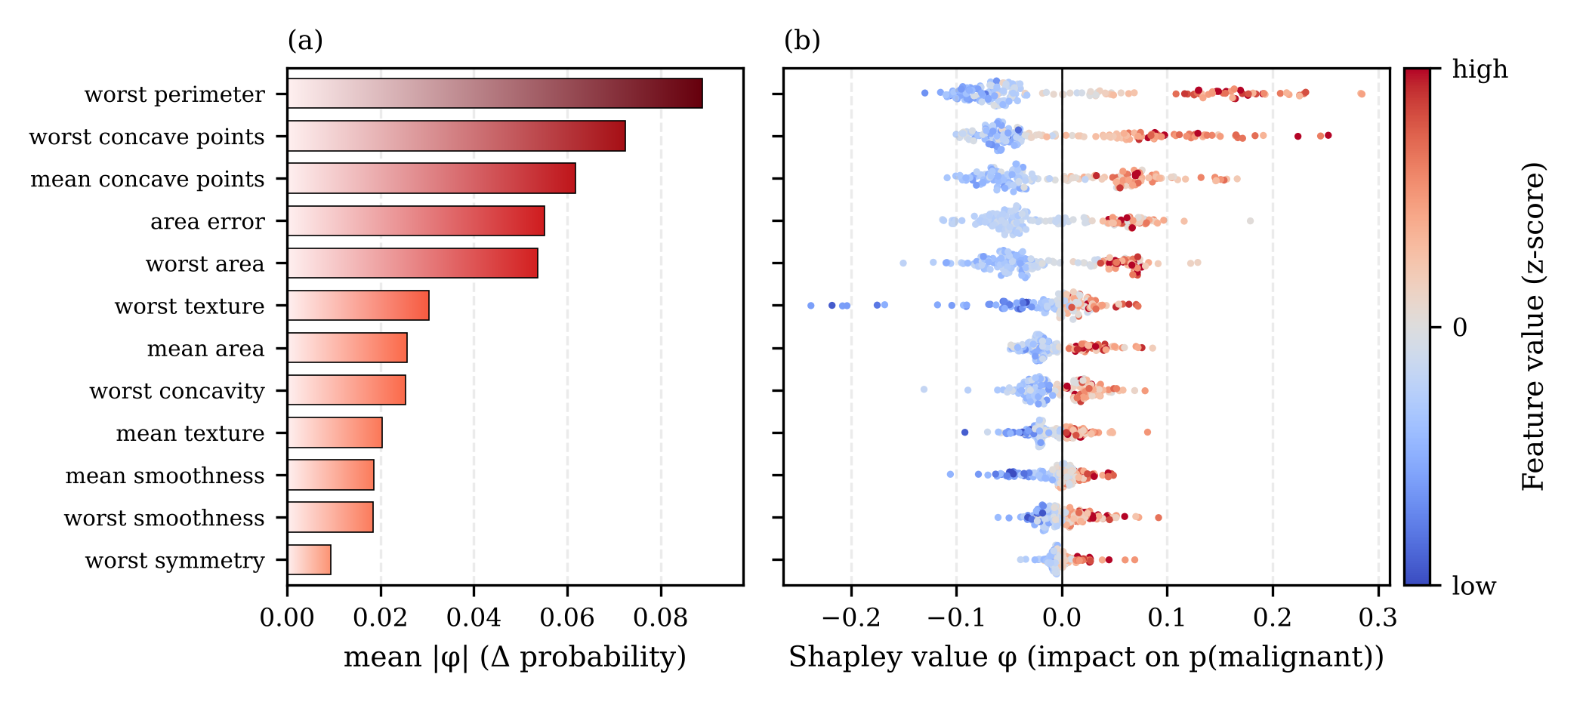
Fig. 7. Global explanation of the HistGB model on BC: (a) mean absolute Shapley value of the 12 most important features; (b) beeswarm of local Shapley values coloured by feature value.

4.7 Image Attributions and Sanity Check (E7)
On DIG, the MLP reaches 97.2% test accuracy. Fig. 8(a) shows that all methods highlight stroke pixels and the gaps that distinguish digits (for example, the open loop of a 5). In the model-randomization test of Fig. 8(b), signed attributions of the trained and randomized networks are essentially uncorrelated (ρ = -0.10 to -0.02), so every method passes the sanity check when sign is retained. Absolute-value maps, however, remain substantially similar after randomization (ρ = 0.59–0.61) because they correlate strongly with input intensity (ρ(|φ|, |x|) = 0.74–0.79). Visually convincing magnitude maps therefore reflect the input more than the model, so signed maps are preferred for verification.

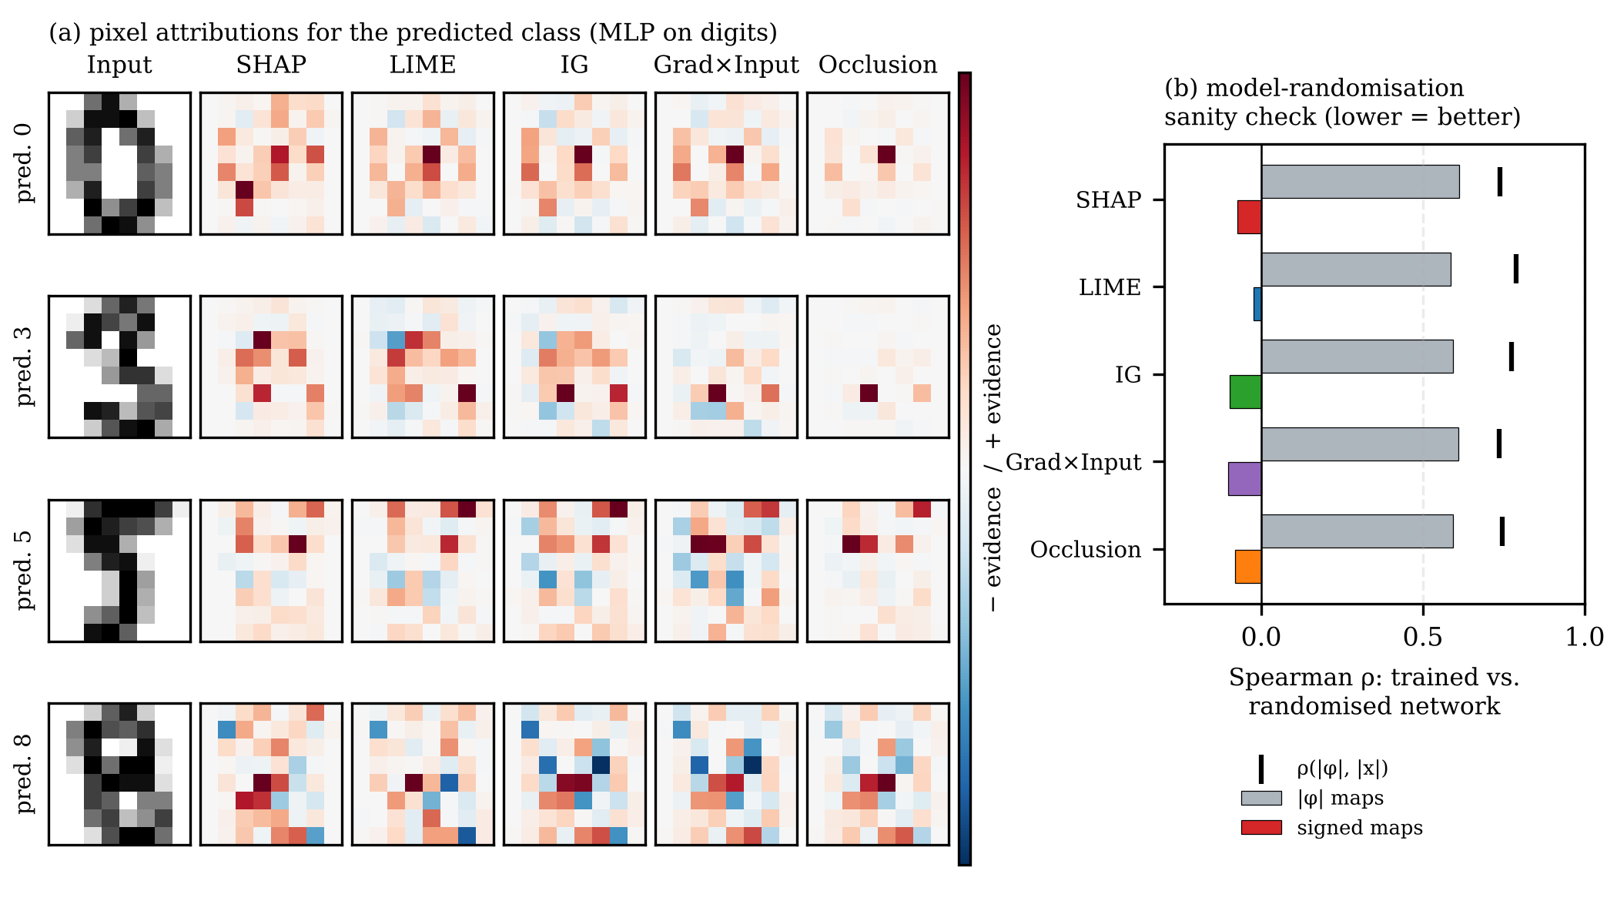
Fig. 8. (a) Pixel attributions for the predicted class of four test digits (red: evidence for, blue: against); (b) model-randomization sanity check: Spearman correlation between explanations of the trained and randomized MLP for absolute and signed maps; tick marks: correlation of |φ| with input intensity.

4.8 Shortcut Detection (E8)
Table 7 and Fig. 9 show the value of explanations for model auditing. With the injected artefact, both models reach near-perfect validation AUC (0.999), which would pass a standard accuracy check. Shapley-based global importance, however, ranks the artefact first for both HistGB (26% of total attribution) and the MLP (12%). At deployment, where the artefact is uninformative, HistGB's AUC falls to 0.951 and its accuracy to 92.4%. Retraining without the flagged feature restores AUC to 0.978 (accuracy 94.2%). The MLP is more robust (0.983 vs. 0.987), but the explanation flags the same risk. Explanations thus reveal "Clever Hans" behaviour that accuracy metrics hide.
TABLE 7: Shortcut detection with an injected artefact (BC)
Model | Artefact | AUC val. | AUC deploy | Acc. deploy | Artefact rank | Artefact share
HistGB | present | 0.999 | 0.951 | 92.4% | #1 | 25.9%
HistGB | removed | 0.994 | 0.978 | 94.2% | — | —
MLP | present | 0.999 | 0.983 | 95.3% | #1 | 12.0%
MLP | removed | 0.994 | 0.987 | 95.9% | — | —

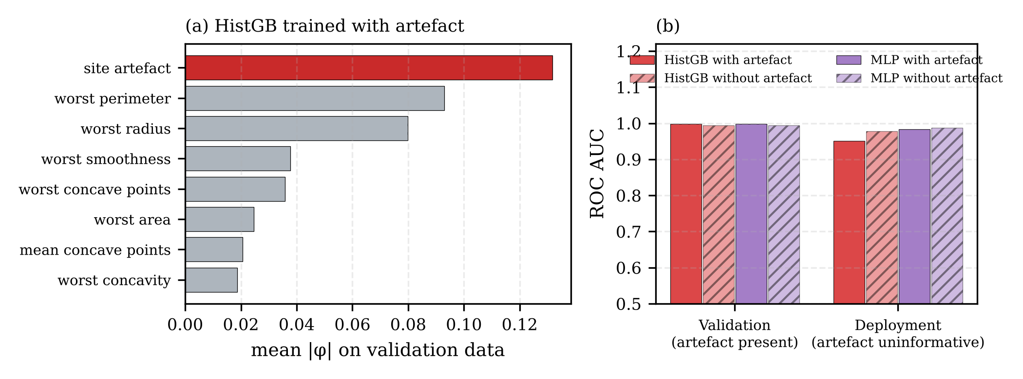
Fig. 9. Shortcut detection: (a) global Shapley importance of HistGB trained with the artefact; (b) AUC on validation data (artefact informative) and at deployment (artefact uninformative), with and without the artefact.

4.9 Counterfactual Recourse (E9)
Table 8 and Fig. 10 compare counterfactual generators on DIAB. All methods are valid, but they differ sharply in usefulness. Nearest unlike neighbours are perfectly plausible (they are real patients) but change 8.3 of 10 features on average, and they almost never respect the immutable attributes (actionable in 3–10% of cases), so they cannot serve as recourse. Unconstrained growing spheres find much closer counterfactuals (L1 0.60 for HistGB) but change age or sex in 73% of MLP cases. The actionable variant guarantees 100% actionability with sparse changes (2.4 features for HistGB, 4.3 for the MLP) at a modest cost in plausibility (1.21 vs. a value of 1 at typical neighbour distance). In the example of Fig. 10(a), the predicted probability of high progression falls from 0.85 to 0.46 after small changes to blood pressure and s3 (HDL). That such small changes flip the MLP decision also reveals a fragile decision boundary near this patient, a trust-relevant diagnostic in its own right. Because counterfactuals describe the model rather than causal effects, they must be presented with that caveat.
TABLE 8: Counterfactual explanations on DIAB (40 patients)
Model | Method | Valid | Actionable | # changed | L1 | Implaus. | ms
HistGB | NUN | 100% | 3% | 8.3 | 4.12 | 0.00 | 0.0
 | GS | 100% | 80% | 2.6 | 0.60 | 1.16 | 103.4
 | GS-actionable | 100% | 100% | 2.4 | 0.56 | 1.15 | 97.4
MLP | NUN | 100% | 10% | 8.3 | 4.21 | 0.00 | 0.0
 | GS | 100% | 28% | 5.0 | 1.07 | 1.23 | 26.1
 | GS-actionable | 100% | 100% | 4.3 | 1.03 | 1.21 | 14.9
Immutable features: age and sex. Implausibility: distance to the nearest training point of the target class divided by the median nearest-neighbour distance.

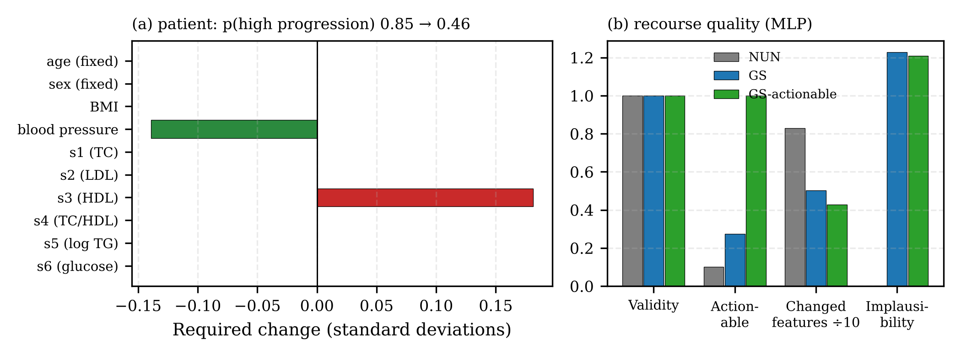
Fig. 10. Counterfactual recourse on DIAB: (a) actionable counterfactual for one patient (age and sex fixed); (b) quality of the three generators for the MLP.

4.10 Calibrated Selective Prediction (E10)
Explanations are only half of a trustworthy decision. The other half is knowing when to trust the prediction. Table IX shows that the black boxes are badly overconfident on the small, noisy DIAB task (ECE 0.198 for HistGB and 0.254 for the MLP). Platt scaling reduces their ECE to 0.060 and 0.088 and also improves accuracy and log-loss. Calibration is not universally beneficial, however: on BC and DIG, where the models were already well calibrated, recalibration increased ECE (for example, from 0.016 to 0.160 for LR on DIG, owing to one-vs-rest normalization). Calibration must therefore be validated rather than applied by default. With calibrated confidence, deferring the 20% least-confident DIAB cases to a clinician raises the accuracy of the automated decisions from 71.3% to 76.6% for HistGB and from 74.7% to 80.2% for LR (Fig. 11(b)). On BC and DIG, the automated subset becomes almost error-free.
TABLE 9: Calibration and selective prediction (5-fold out-of-fold)
Data · model | Acc. | ECE raw | ECE Platt | Acc@90% | Acc@80% | AURC
BC · LR | 97.7 | 0.016 | 0.045 | 99.2 | 99.8 | 0.002
BC · HistGB | 97.0 | 0.021 | 0.027 | 99.2 | 99.6 | 0.003
BC · MLP | 97.7 | 0.018 | 0.027 | 99.2 | 99.1 | 0.013
DIAB · LR | 74.7 | 0.055 | 0.039 | 77.6 | 80.2 | 0.121
DIAB · HistGB | 71.3 | 0.198 | 0.060 | 75.1 | 76.6 | 0.160
DIAB · MLP | 71.0 | 0.254 | 0.088 | 74.1 | 76.8 | 0.199
DIG · LR | 96.8 | 0.016 | 0.160 | 98.8 | 99.3 | 0.004
DIG · HistGB | 97.1 | 0.013 | 0.114 | 99.6 | 99.9 | 0.002
DIG · MLP | 97.6 | 0.010 | 0.070 | 99.3 | 99.6 | 0.005
Accuracy, selective accuracy (Acc@coverage), and AURC for the Platt-calibrated models; AURC: area under the risk–coverage curve (lower is better).

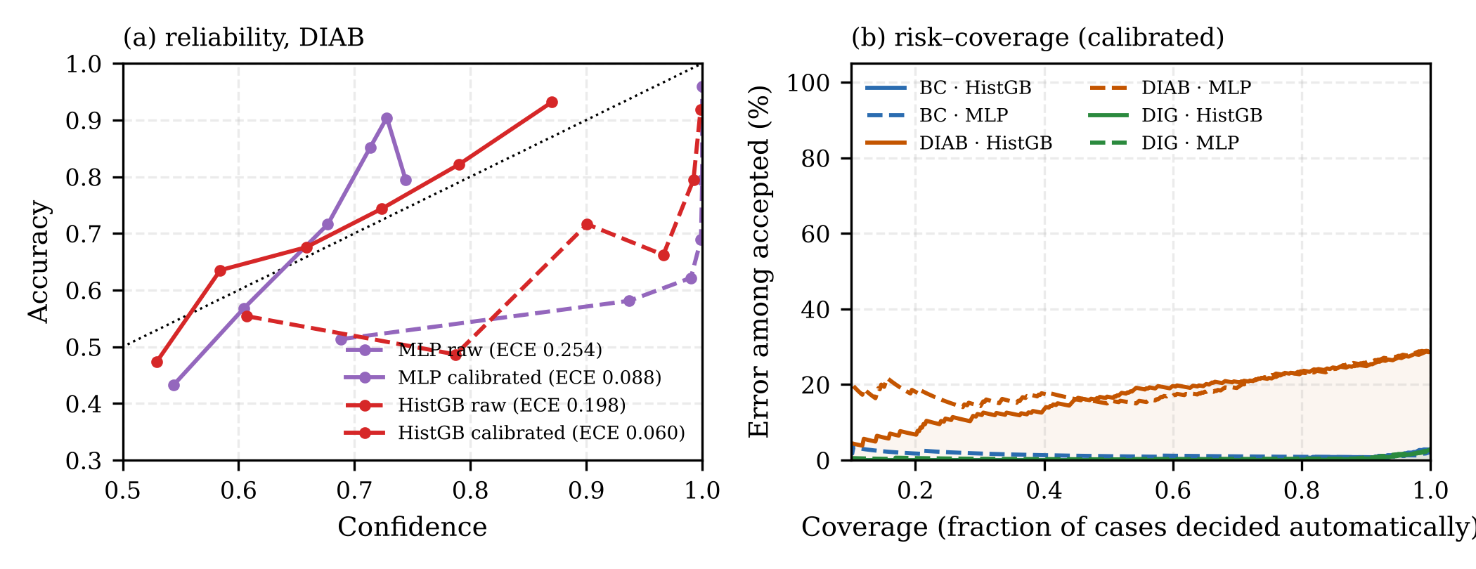
Fig. 11. (a) Reliability diagrams on DIAB before (dashed) and after (solid) Platt scaling; (b) risk–coverage curves of calibrated models: error among automatically decided cases as the coverage decreases.

5. Discussion

5.1 Guidelines for Trustworthy XAI
The results support six practical guidelines:
- Start with interpretable models. On tabular clinical data, LR and GAMs matched or beat black boxes. A black box should be justified by a demonstrated accuracy gain, as on SYN.
- Match the explainer to the model. Gradient-based methods must not be used on tree ensembles. SHAP is the most correct general-purpose choice, and LIME is the most stable and cheapest perturbation method.
- Evaluate explanations before trusting them. Faithfulness, stability, and sanity checks are inexpensive (all experiments ran on a laptop-class CPU) and should be part of model validation, just as accuracy is.
- Report explanation uncertainty. Sampling-based attributions vary between runs; repeated runs or confidence intervals should accompany explanations used in contested decisions.
- Use explanations for auditing, not only for justification. Global attributions exposed a shortcut that a 0.999 validation AUC concealed.
- Combine explanations with calibrated confidence and actionable recourse. Calibrated deferral improved decision accuracy, and actionability constraints turned counterfactuals into meaningful recourse.

5.2 Challenges
Explanation methods can be manipulated by adversarial models [16]. Disagreement among methods complicates accountability [17]. Feature attributions describe association rather than causation, and different stakeholders, such as clinicians, data scientists, regulators, and affected individuals, need different explanations [30]. Regulatory requirements such as transparency to deployers and human oversight [2] are not yet linked to measurable thresholds for explanation quality, and the multi-criteria metrics used here offer a starting point for doing so.

5.3 Emerging Opportunities
Promising directions include causal and interventional explanations that respect feature dependencies; explanation methods with formal guarantees, such as exact Shapley values for tree models and certified-robust attributions; natural-language explanations generated by large language models, provided they are grounded in faithful attributions; and human-centred evaluation that measures whether explanations actually improve decisions and calibrate user trust.

5.4 Limitations
The benchmark uses small and medium-sized public datasets and a single synthetic generator, and functional metrics do not replace user studies. Deletion-based faithfulness depends on the choice of baseline, which here is the training mean. Shapley values were estimated with a moderate sampling budget, and the counterfactual search ignores causal relationships between features. Future work will extend the evaluation to deep image and text models, larger tabular benchmarks, and controlled studies with domain experts.

6. Conclusion
This paper proposed a framework for trustworthy decision-making that treats explanations as verifiable components of an intelligent system. Using real clinical and image datasets and a ground-truth benchmark, it showed that interpretable models often suffice for tabular decisions; that explanation methods differ markedly in correctness, faithfulness, stability, and cost, with SHAP the most correct and gradient methods unreliable on tree ensembles; that methods frequently disagree; and that sign-aware sanity checks are needed to separate model evidence from input intensity. Explanations also proved operationally valuable: they exposed a shortcut that standard validation missed, generated actionable recourse, and, combined with calibrated confidence, allowed uncertain cases to be deferred to humans with a measurable gain in accuracy. Explainability is therefore a property to be engineered and tested, not assumed, and the open benchmark provided supports that practice.

References
[1] European Parliament and Council, “Regulation (EU) 2016/679 (General Data Protection Regulation),” Off. J. Eur. Union, vol. L 119, pp. 1–88, 2016.
[2] European Parliament and Council, “Regulation (EU) 2024/1689 laying down harmonised rules on artificial intelligence (Artificial Intelligence Act),” Off. J. Eur. Union, 2024.
[3] National Institute of Standards and Technology, “Artificial Intelligence Risk Management Framework (AI RMF 1.0),” NIST AI 100-1, Gaithersburg, MD, USA, 2023.
[4] F. Doshi-Velez and B. Kim, “Towards a rigorous science of interpretable machine learning,” arXiv:1702.08608, 2017.
[5] A. Adadi and M. Berrada, “Peeking inside the black-box: A survey on explainable artificial intelligence (XAI),” IEEE Access, vol. 6, pp. 52138–52160, 2018.
[6] A. Barredo Arrieta et al., “Explainable artificial intelligence (XAI): Concepts, taxonomies, opportunities and challenges toward responsible AI,” Inf. Fusion, vol. 58, pp. 82–115, 2020.
[7] D. Gunning and D. W. Aha, “DARPA’s explainable artificial intelligence (XAI) program,” AI Mag., vol. 40, no. 2, pp. 44–58, 2019.
[8] M. T. Ribeiro, S. Singh, and C. Guestrin, “‘Why should I trust you?’: Explaining the predictions of any classifier,” in Proc. 22nd ACM SIGKDD Int. Conf. Knowl. Discovery Data Mining, 2016, pp. 1135–1144.
[9] S. M. Lundberg and S.-I. Lee, “A unified approach to interpreting model predictions,” in Proc. Adv. Neural Inf. Process. Syst. (NeurIPS), vol. 30, 2017, pp. 4765–4774.
[10] M. Sundararajan, A. Taly, and Q. Yan, “Axiomatic attribution for deep networks,” in Proc. 34th Int. Conf. Mach. Learn. (ICML), 2017, pp. 3319–3328.
[11] S. Wachter, B. Mittelstadt, and C. Russell, “Counterfactual explanations without opening the black box: Automated decisions and the GDPR,” Harvard J. Law Technol., vol. 31, no. 2, pp. 841–887, 2018.
[12] C. Rudin, “Stop explaining black box machine learning models for high stakes decisions and use interpretable models instead,” Nature Mach. Intell., vol. 1, no. 5, pp. 206–215, 2019.
[13] W. Samek, A. Binder, G. Montavon, S. Lapuschkin, and K.-R. Müller, “Evaluating the visualization of what a deep neural network has learned,” IEEE Trans. Neural Netw. Learn. Syst., vol. 28, no. 11, pp. 2660–2673, 2017.
[14] D. Alvarez-Melis and T. S. Jaakkola, “On the robustness of interpretability methods,” arXiv:1806.08049, 2018.
[15] J. Adebayo, J. Gilmer, M. Muelly, I. Goodfellow, M. Hardt, and B. Kim, “Sanity checks for saliency maps,” in Proc. Adv. Neural Inf. Process. Syst. (NeurIPS), vol. 31, 2018, pp. 9505–9515.
[16] D. Slack, S. Hilgard, E. Jia, S. Singh, and H. Lakkaraju, “Fooling LIME and SHAP: Adversarial attacks on post hoc explanation methods,” in Proc. AAAI/ACM Conf. AI, Ethics, Soc. (AIES), 2020, pp. 180–186.
[17] S. Krishna et al., “The disagreement problem in explainable machine learning: A practitioner’s perspective,” arXiv:2202.01602, 2022.
[18] T. Hastie and R. Tibshirani, Generalized Additive Models. London, U.K.: Chapman & Hall, 1990.
[19] Y. Lou, R. Caruana, J. Gehrke, and G. Hooker, “Accurate intelligible models with pairwise interactions,” in Proc. 19th ACM SIGKDD Int. Conf. Knowl. Discovery Data Mining, 2013, pp. 623–631.
[20] E. Štrumbelj and I. Kononenko, “Explaining prediction models and individual predictions with feature contributions,” Knowl. Inf. Syst., vol. 41, no. 3, pp. 647–665, 2014.
[21] M. D. Zeiler and R. Fergus, “Visualizing and understanding convolutional networks,” in Proc. Eur. Conf. Comput. Vis. (ECCV), 2014, pp. 818–833.
[22] M. Ancona, E. Ceolini, C. Öztireli, and M. Gross, “Towards better understanding of gradient-based attribution methods for deep neural networks,” in Proc. Int. Conf. Learn. Represent. (ICLR), 2018.
[23] L. S. Shapley, “A value for n-person games,” in Contributions to the Theory of Games II, H. W. Kuhn and A. W. Tucker, Eds. Princeton, NJ, USA: Princeton Univ. Press, 1953, pp. 307–317.
[24] T. Laugel, M.-J. Lesot, C. Marsala, X. Renard, and M. Detyniecki, “Inverse classification for comparison-based interpretability in machine learning,” arXiv:1712.08443, 2017.
[25] S. Hooker, D. Erhan, P.-J. Kindermans, and B. Kim, “A benchmark for interpretability methods in deep neural networks,” in Proc. Adv. Neural Inf. Process. Syst. (NeurIPS), vol. 32, 2019.
[26] C. Guo, G. Pleiss, Y. Sun, and K. Q. Weinberger, “On calibration of modern neural networks,” in Proc. 34th Int. Conf. Mach. Learn. (ICML), 2017, pp. 1321–1330.
[27] Y. Geifman and R. El-Yaniv, “Selective classification for deep neural networks,” in Proc. Adv. Neural Inf. Process. Syst. (NeurIPS), vol. 30, 2017.
[28] S. Lapuschkin, S. Wäldchen, A. Binder, G. Montavon, W. Samek, and K.-R. Müller, “Unmasking Clever Hans predictors and assessing what machines really learn,” Nature Commun., vol. 10, Art. no. 1096, 2019.
[29] R. Geirhos et al., “Shortcut learning in deep neural networks,” Nature Mach. Intell., vol. 2, no. 11, pp. 665–673, 2020.
[30] T. Miller, “Explanation in artificial intelligence: Insights from the social sciences,” Artif. Intell., vol. 267, pp. 1–38, 2019.
[31] W. N. Street, W. H. Wolberg, and O. L. Mangasarian, “Nuclear feature extraction for breast tumor diagnosis,” in Proc. SPIE, vol. 1905, Biomedical Image Processing and Biomedical Visualization, 1993, pp. 861–870.
[32] B. Efron, T. Hastie, I. Johnstone, and R. Tibshirani, “Least angle regression,” Ann. Statist., vol. 32, no. 2, pp. 407–499, 2004.
[33] E. Alpaydin and C. Kaynak, “Optical recognition of handwritten digits,” UCI Machine Learning Repository, 1998, doi: 10.24432/C50P49.
[34] L. Breiman, “Random forests,” Mach. Learn., vol. 45, no. 1, pp. 5–32, 2001.
[35] J. H. Friedman, “Greedy function approximation: A gradient boosting machine,” Ann. Statist., vol. 29, no. 5, pp. 1189–1232, 2001.
[36] F. Pedregosa et al., “Scikit-learn: Machine learning in Python,” J. Mach. Learn. Res., vol. 12, pp. 2825–2830, 2011.
[37] J. C. Platt, “Probabilistic outputs for support vector machines and comparisons to regularized likelihood methods,” in Advances in Large Margin Classifiers. Cambridge, MA, USA: MIT Press, 1999, pp. 61–74.

