Journal of Integrated Scientific Research (JISR)

https://jisrjournal.com/

Generative Artificial Intelligence in Software Engineering: Enhancing Code Generation, Testing, and Developer Productivity
Suresh Babu Narra
IEEE Senior Member
Solutions Architect – AI, Machine Learning & Generative AI
Cincinnati, Ohio, USA
Email: narra.sureshbabu@gmail.com
Abstract
This study examines the impact of generative synthetic intelligence (GenAI) on software program construction, testing, and maintenance; however, because proprietary models and non-reproducible environments limit reproducibility, insufficient evidence exists to pinpoint the conditions under which GenAI can have an influence. This study examines how generative AI (GenAI) influences software development, testing, and maintenance, but because proprietary models and environments cannot be reproduced, it is difficult to determine when and how GenAI exerts influence. This paper introduces a fully reproducible lab study in which we test models trained from scratch on generative code from 8.5 million characters of real Python standard-library code end-to-end across three software-engineering tasks: code generation, testing, and developer assistance. Attempts are made to compare how these models perform on held-out files, using character-level n-gram models and a 2.24-million-parameter neural language model, as well as a mixture of these. With the hybrid model, cross-entropy is 1.403 bits per character (19.1% less than the best n-gram model), and the fraction of correctly predicted next characters is 74.1%. The neural model completes 10.7% of held-out lines, compared with 0.3% for the 6-gram model. For perplexity, lower perplexity does not mean better generation; for sampling, likelihood-based sampling doubles exact-match at moderate temperature. The number of verbatim reproduced training code increases by a factor of 5 from the 4-gram to the 10-gram model (4.5% to 23.9% of 32-character windows at T = 0.5) and decreases as the temperature drops—only the largest n-gram has the overlap value human-written code has naturally with the corpus (23.9%). For three pure-Python parsers, a language-dedicated generator (GenAI sampling and mutation of actual Python code) is more effective than random inputs in the case of the Python unparser but not for parsers of other languages. When coverage feedback was added, the percentage of valid generated inputs also rose (from 2% to 65%), but the coverage decreased this time, demonstrating this trade-off between validity and diversity. An inline suggestion can save 2-32.1% of keystrokes, and we can tune it according to the acceptance rate and saving rate using a keystroke-level simulation. The results provide strong recommendations for using GenAI in software engineering, including the release of all code and data.

Keywords – Generative AI, large language models, code generation, code completion, pass@k, fuzz testing, test generation, developer productivity, memorization, software engineering.
1. INTRODUCTION
With the right training data, a source code language model can now be used to generate a function from a natural language description, be used as a code completion system while the programmer types, and can even generate test arguments [1]–[3]. There are millions of developers using commercial assistants based on such models, and well-scoped programming tasks are reported to cost much less with such an assistant [4]. As such, software engineering (SE) is among the first professional fields to be widely using generative artificial intelligence (GenAI) [5] [6].
The evidence base has three weaknesses. First, most evaluations rely on proprietary models whose training data, model size, and decoding parameters are not disclosed, making replication and explanation difficult. Second, decisions that the practitioner is required to take (e.g., the decoding temperature or selecting between different samples) are not directly reflected in the accuracy on curated benchmarks, nor is the use of a generator to test. Third, benefits and hazards are often examined individually rather than in conjunction, including verbatim copying of training code [7] and insecure or incorrect output [9] and [10].
This paper adopts a complementary approach, similar to a laboratory approach. Instead of comparing the quality of a black-box service, this paper builds generative code models from scratch on a publicly available corpus, and quantifies (according to one protocol) the quality of such models by the impact of modelling decisions on code generation, testing and developer productivity. The models are deliberately kept small and not state-of-the-art, meaning the study does not claim state-of-the-art accuracy. This is because its value is transparency: each number can be reproduced on a typical CPU, and each mechanism can be altered individually. The offers that are made are as follows:
- An end-to-end, open experimental framework that is linked to a code corpus and generative models, to three SE activities and quality and risk gates (Fig. 1).
- Statistical vs. neural generative code – comparison of predictive quality, data scaling, and correctness of the different types of token-generated data.
- Analysis of sampling temperature, pass@k, and sample selection in the context of code completion, as well as syntax correctness of generated functions and verbatim memorization of these functions.
- Systematic comparisons of random, mutation, and GenAI-based fuzzing on three pure-Python parsers, discovering a validity–diversity trade-off in feedback-driven generation.
Key-stroke-level productivity simulation, which translates the suggestion acceptance – effort savings trade-off into numbers.
The related work is presented in Section 2. Section 3 outlines the framework and methods; Section 4 details the findings; Section 5 outlines the implications and threats to validity; and Section 6 presents the conclusion.
2. Students will gain knowledge of the background and related work.
2.1 Models of Code
Hindle et al. demonstrated that source code is very repetitive and predictable, and that an n-gram model of languages better represents such "naturalness" of source code than it does natural language [11]. Then, completeness of code was provided from a statistical model [12, 13], and the field has been surveyed by Allamanis et al. [14]. This idea got scaled up to billions of parameters, first by using neural language models [15] and subsequently Transformer architectures [16]. Functional code-synthesis capabilities have been demonstrated by Codex [1], AlphaCode [17], and models tested on MBPP [2], and recent surveys provide a list of applications throughout the SE life cycle [5] and [6].
2.2 Explaining Generated Code
One of the most frequently used metrics of functional correctness is pass@k, the probability that, for a given sample set of k samples, at least one passes the unit tests, estimated (with no bias) from among n>k samples [1]. Many solutions which superficially appear correct are incorrect when tested with more rigorous tests [10]. A key feature of systems like AlphaCode [17] is the creation of numerous samples and the selection of them by likelihood, clustering or by execution of tests. The temperature decoding controls the diversity/precision trade-off [1, 18].
2.3 C. Generative AI for Software Testing: A Blueprint for the Future
Fuzzing runs a software program with varied pressure data [19, 20] that are generated in massive numbers. Learning-based fuzzers generate models and use the generative models to generate structured inputs [21] Large language models (LLMs) have been utilized to conquer coverage plateaus in search-based unit-test generation (SBUTG) [22], to directly generate unit tests [23], as well as to fuzz the deep-learning libraries and compiler [24], [25]. A question that comes up regularly is what proportion of the model's benefit comes from knowledge of the input language, and what comes from the feedback loop.
2.4 Productivity and Risks of Generative AI
In a randomized experiment on AI pair programming, it was revealed that developers with an AI pair-programmer could perform a task 55.8% faster [4], while suggestion acceptance rate has been identified as a good indicator of perceived productivity [26]. Developers explore and interact with assistants in different modes: acceleration and exploration [27]. Risks include insecure suggestions [9], over-reliance on the generated code by users [28] and concerns about the memorization of training data [7] [8], which might lead to code being plagiarized or code licensing issues. Table 1 summarizes how each theme in this study is operationalized.
TABLE 1: HARVEY JONES FOURTH EDITION GENAI IN SOFTWARE ENGINEERING: THEMES AND EXPERIMENTS 2006-2007 EXAMINATIONS
Theme | Representative work | Question studied here | Exp.
Code modelling | [1], [11], [14] | How much do context and model class matter? | E1
Code generation | [1], [2], [17] | How do temperature and selection affect pass@k? | E2
Quality & licensing | [7], [8], [10] | Are generated functions valid? Are they copied? | E3
Testing | [21], [22], [25] | When does generative fuzzing increase coverage? | E4
Productivity | [4], [26], [27] | What do suggestions save, at what acceptance? | E5

3. Framework and Methodology

3.1 Experimental Framework
Fig. 1 shows the framework. A corpus of real source code is split by file, generative models are trained on the training partition, and the models serve three SE activities: code generation (E2, E3), testing (E4), and developer assistance (E5). Each activity passes through quality and risk gates: syntax or test verification, a memorization check against the training data, a calibrated threshold for showing suggestions, and coverage feedback. Developer actions and new code close the loop.

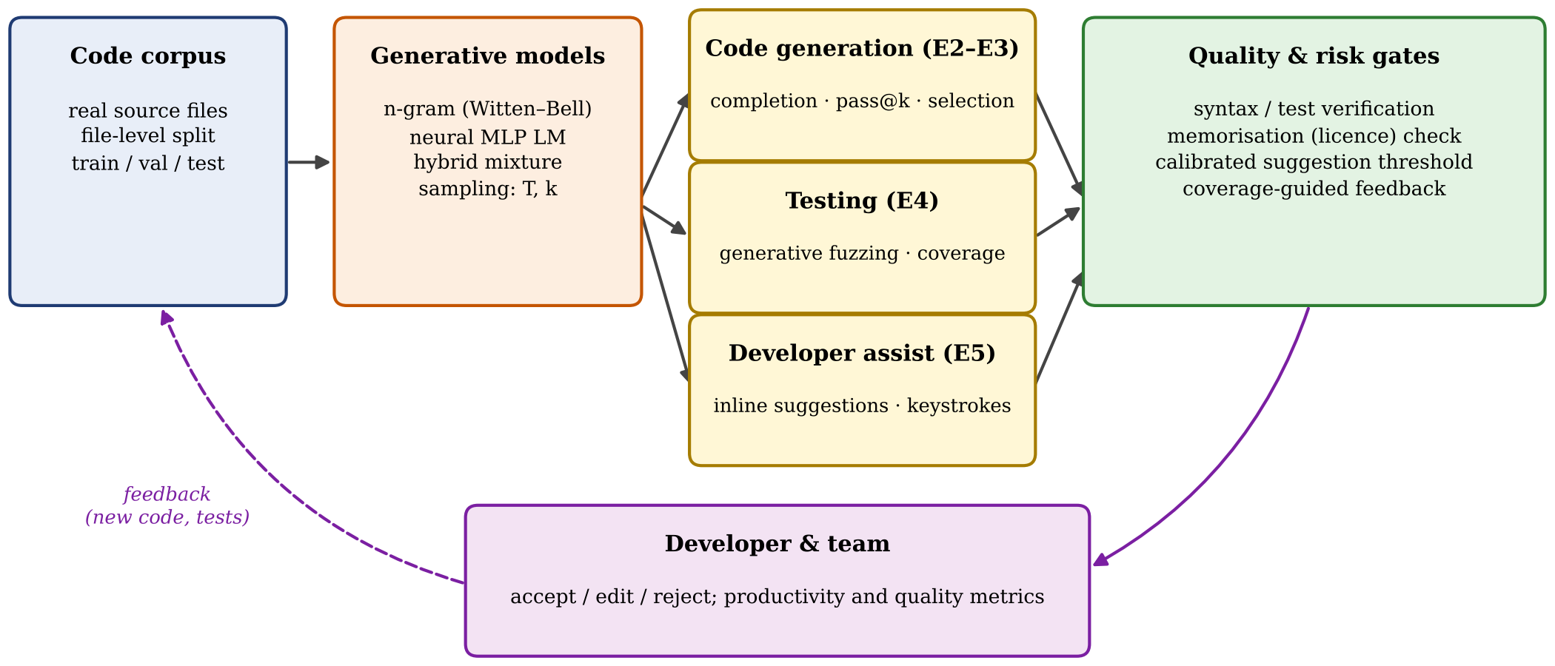
Fig. 1. Experimental framework for studying GenAI in software engineering. E1–E5 denote the experiments of Section 4.

3.2 Corpus
The corpus consists of the pure-Python modules of the CPython 3.13 standard library, a large, professionally maintained, and openly licensed code base. Test suites and the IDLE editor are excluded. To prevent leakage between training and evaluation, the split is made at the file level: 429 files for training, 53 for validation, and 55 for testing (Table 2). Characters are modelled directly (96 printable ASCII symbols plus newline and an unknown symbol, which covers 0.01% of characters), which makes keystroke-level analysis exact and avoids tokenizer-dependent effects.
TABLE 2: Code corpus (file-level split)
Partition | Files | Characters | Use
Training | 429 | 8,460,970 | model fitting
Validation | 53 | 865,420 | mixture weight, early checks
Test | 55 | 971,027 | all evaluations

3.3 Generative Models
n-gram models. The probability of the next character, c, in the sequence of length n > 1 that follows the history (the first n − 1 characters) h is calculated using interpolated Witten–Bell smoothing for the orders 2 to 10 as follows:
P(c|h) = [C(h,c) + N1+(h) P(c|h′)] / [C(h) + N1+(h)] (1)
where C(·) are training counts, N1+(h) is the number of distinct characters that were observed after h, and h′ is h without the oldest character. Counts are kept in sorted 64-bit hash tables for vectorized look-up.
Neural model. In a neural probabilistic language model, the previous 64 characters (32 dimensions each) are embedded, then processed by two ReLU layers (each with 768 dimensions); a residual connection is inserted, and a softmax over the vocabulary (2.24 M parameters) is computed. It was trained with Adam on 7.2 M random training windows with a cosine learning-rate schedule (46 min on two CPU cores).
Hybrid. Both neural and the 6-gram models are linearly interpolated, P = λP6g + (1 − λ)PMLP; λ = 0.45 is selected on the validation files. Texts are autoregressively generated from the temperature-scaled distribution PT(c) ∝ P(c)1/T with T = 0, which corresponds to greedy decoding.
3.4 Experiments and Metrics
Modelling quality: test cross-entropy in bits per character (BPC) ( −(1/N)Σ log2P(xi|x<i) ), accuracy in recognising the next character (N, 20,000 random test positions, by Python token category (using the standard tokenizer) and data scaling (on nested subsets of the training files).
E2, line completion: a minimum of 300 non-comment test lines, at least 12 characters long, are cut after their indentation plus 30% of their contents, and the model is required to print the rest out exactly. For each line, n = 20 samples are drawn at T ∈ {0.2, 0.5, 0.8, 1.0}, and pass@k is estimated without bias:
pass@k = Elines[1 − C(n − c, k) / C(n, k)] (2)
The number of exact matches in the n samples is c. Three selection strategies (random sample, maximum likelihood, and majority vote) are taken as comparisons to greedy decoding and the oracle pass@20.
In function generation (E3 mode), each model is able to produce 400 characters for 150 function headings from test files. The body is indented according to the first dedent, and the function is compiled using the compiler provided by Python (Python compilation). The copy rate is defined as the percentage of output windows (32 characters) that contain more than 60% non-blank characters and at least eight different characters identical to those in the training corpus. The same measure taken on the test code written by a human yields the natural baseline.
Generative fuzzing, round 5 (E4): 1,500 samples generated per approach: Uniformly random characters; AFL-style mutation of real code snippets (character flips, insertions, deletions, duplications, and splices); Un-guided GenAI sampling from short generic prompt; GenAI with coverage feedback: Generative fuzzing guided by code coverage feedback for snippets (prefixes of samples are used as prompts); GenAI with target-aligned feedback: Generative fuzzing guided by target-specific code coverage feedback for snippets (prefixes of samples are used as prompts). There are three pure-Python components that process each input: the AST unparser (ast.unparse, can only be reached when fed syntactically valid Python), the TOML parser (tomllib), and the regular-expression parser (re._parser). A syntactically valid line-prefix (a prefix to a line of code) that is longest is passed from a uniform harness to the unparser. The line is mapped using trace, and we use 5 seeds for each configuration.
Simulated by a simulated typing developer typing 42.2 k characters of 8 held-out files (E5 Productivity Simulation). At each position, the model's "greedy" completion up to the end of the line is cut short to its longest prefix with a joint probability of at least some threshold value τ. If 2 or more characters are there, the suggestion is displayed and typing the next character is accepted if it matches the next character that will appear (one key). The metrics are
Saving = 1 − K/N, Acceptance = A/S (3)
((K * N) + A) / S, where K = the number of keystrokes, N = the number of characters, A = accepted suggestions and S = suggestions shown.
3.5 Reproducibility
All models, metrics, and experiments have been done in Python using the NumPy library only. The code, trained weights and all the result files are made public, and a full run is carried out in approximately 2 hours with a two-core CPU.
4. RESULTS
4.1 Modelling Quality (E1)
The models are compared in Table 3 and Fig. 2. In an n-gram model, cross-entropy drops sharply up to order 7 (1.734 BPC) and then increases again (n = 10: 1.856 BPC) because the context is too broad for the amount of data used. The neural model, which conditions on 64 characters, achieves 1.544 BPC (11.0% below the best n-gram), and the hybrid achieves 1.403 BPC (19.1% below). This indicates that there are regularities that are captured in both statistical and neural models. The 10-gram is not as accurate as the 6-gram in terms of BPC, but more accurate than the 6-gram in terms of top-1 accuracy: It is overconfident on codes that occur more than once, but underconfident on codes that appear less often. Scaling the data (Fig. 2(b)) reveals that a 6-gram achieved on 1/32 of the corpus (0.18 M characters) reaches 2.85 BPC, and the lower curve in the figure indicates that it reaches 1.74 BPC on the full corpus – a relationship between corpus size and BPC which follows a log-linear trend and is far from being saturated. The loss of the neural model was still decreasing at the end of training (Fig. 2(c)).
TABLE 3: Generative code models on held-out test files
Model | Size | BPC | Top-1 (%) | Top-5 (%) | ms / 40 char
4-gram | 0.33 M entries | 1.930 | 64.5 | 86.5 | 7
6-gram | 1.77 M entries | 1.735 | 70.1 | 89.0 | 9
10-gram | 9.52 M entries | 1.856 | 73.8 | 90.1 | 17
Neural (MLP) | 2.24 M params | 1.544 | 71.0 | 88.6 | 25
Hybrid | both | 1.403 | 74.1 | 90.5 | 55
BPC: test cross-entropy in bits per character (lower is better). Latency: greedy generation of 40 characters for one context on a two-core CPU.

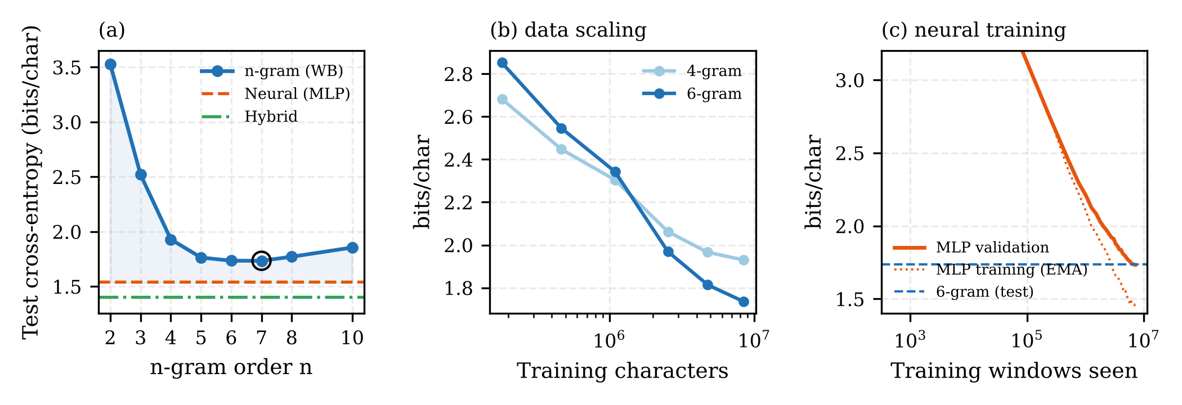
Fig. 2. The results of modelling quality are shown in the following figures, with the accuracy of the test cross-entropy of n-gram models by order for neural and hybrid models, the data scaling of 4- and 6-gram models and the training curve of the neural model.

Accuracy is measured category-wise for each of the tokens in Fig. 3. Whitespace and indentation are almost perfectly predicted by all models (95% for the hybrid). Operators are the most difficult to classify (55%), as are identifiers (63%), since they contain most of the program-specific information; the difficulty of string classification (64%) is second only to identifiers. The longer context for the neural and hybrid models, where the relevant evidence—what's surrounding a numeric literal, or the structure of an expression—resides outside of the five characters, is what helps the majority of the numbers (57% → 83% from the 6-gram to the hybrid) and operators (42% → 55% from the 6-gram to the hybrid). It's least helpful for identifiers (62% - 63%), which would need to remember names that had been declared much earlier in the file.

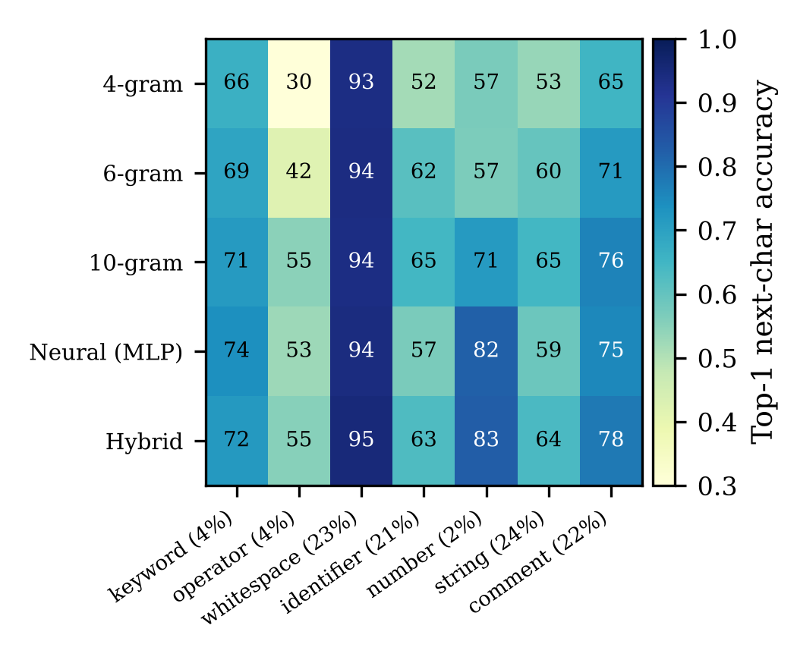
Fig. 3. Top-1 accuracy (%) for next character on Python token category; percentage of Python test characters in each category is shown in parenthesis.
A. Sampling and Selection (E2). B. Code Generation: Sampling and Selection (E2).
The line completion is given in Table 4 and Fig. 4. The greedy decoding model completes 10.7% of lines (edit similarity 0.42) correctly, and the 6-gram only completes 0.3%, so this effect is stronger than the 6-gram. Inspection reveals why: as shown above, pass@1 declines monotonically with temperature while pass@20 increases at moderate temperatures (at small scales reproducing the trade-off reported for large code models)); the neural model, on the other hand, maintains the local structure in the neural context (pass@14.0% at T = 0.2, pass@16.0% at T = 0.5). Selection matters: if T = 0.8, then it is the most likely of 20 that raises exact match from 5.0% (random sample) to 11.3% (above greedy decoding), and majority voting is at 10.3%. Interestingly, a hybrid model with the lowest BPC does not produce as accurate completion as the neural model for all temperatures, e.g., pass@1 3.4% vs. 7.9% at T = 0.5. The interpolated n-gram adds a broader backoff probability mass that leads to better average likelihood, but yields more diverse samples (18.1 vs. 16.4 distinct completions out of 20 samples). By itself, perplexity is not a good measure of the quality of the generation.
TABLE 4: Line completion on 300 held-out lines
Model | Greedy EM (%) | Edit sim. | Best pass@1 (%) | pass@5 (%) | pass@20 (%) | Max-lik. sel. (%)
6-gram | 0.3 | 0.18 | 0.1 (T=0.2) | 0.4 | 0.7 | 0.7
Neural (MLP) | 10.7 | 0.42 | 9.8 (T=0.2) | 10.0 | 14.7 | 11.3
Hybrid | 9.7 | 0.41 | 7.2 (T=0.2) | 3.1 | 8.0 | 5.7
EM: exact match. pass@5, pass@20, and maximum-likelihood selection at T = 0.8 from 20 samples.

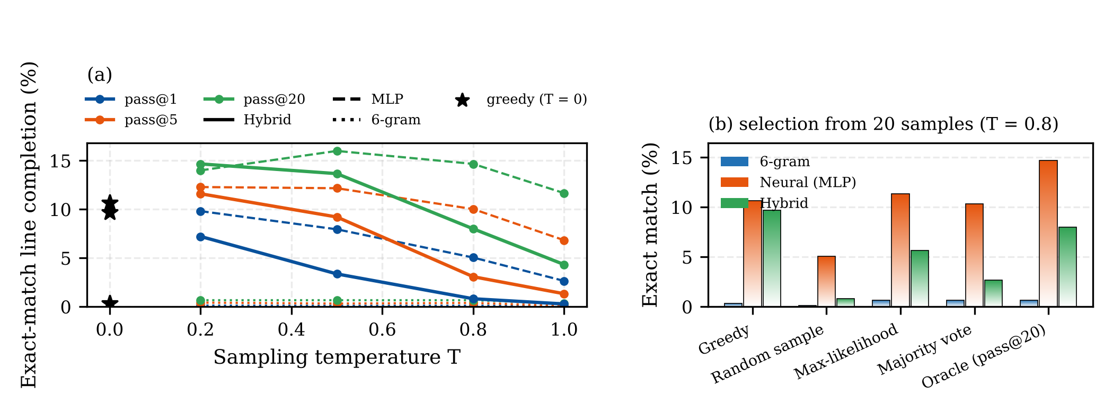
Fig. 4. Code completion for (a) pass@k as a function of sampling temperature (stars: greedy decoding); (b) exact match for different code completion (one of 20 samples) at T = 0.8.

Key Learning Point 4 (KLP4): C. Validity and Memorization of Generated Code (E3)
Function outputs are evaluated in Table 5 and Fig.5. Models are not syntactically valid; even the best ones generate functions that only compile a maximum of 14.7% of the time (neural model, T = 0.8). For the functions that manage to finish within the generation budget, the neural model is compiled 28.1% of the time at T = 0.5. There are few terminated functions (2.7%), and higher conditional rates, like that of the hybrid (50.0%), are not reliable. In small generative models, we have seen results that produce realistic code that rarely compiles, stressing the importance of automated verification of the generated code before it is given to the developers. The Verbatim copying is based on capacity and decoding. As window size (gram) increases, the percentage of content-bearing 32-character windows found verbatim in the training code increases at T = 0.5 and decreases at T = 1.0. Only the highest capacity n-gram at low temp. is at this level of naturalness; held-out code has 23.9% overlap with the corpus using common idioms. Long verbatim spans (64 characters) remain relatively uncommon in the generated code (3.0% most), compared with human-written code (18.1%). This is the pattern of increasing copying in larger models with increasing capacity and more voracious decoding which has been touted for large neural language models [8]. For models of production scale, verbatim filters and provenance-tracking are therefore recommended.
TABLE 5: Generated functions: validity and verbatim copying
Model | T | Valid (%) | Closed (%) | Valid | closed (%) | Copy-32 (%) | Copy-64 (%)
4-gram | 0.5 | 1.3 | 1.3 | 0.0 | 4.5 | 0.0
 | 1.0 | 0.7 | 89.3 | 0.7 | 0.1 | 0.0
6-gram | 0.5 | 2.0 | 2.7 | 0.0 | 8.1 | 0.0
 | 1.0 | 2.7 | 90.0 | 3.0 | 0.9 | 0.0
10-gram | 0.5 | 10.0 | 18.0 | 22.2 | 23.9 | 3.0
 | 1.0 | 6.7 | 84.0 | 7.9 | 5.3 | 0.1
Neural (MLP) | 0.5 | 12.7 | 38.0 | 28.1 | 5.0 | 2.0
 | 1.0 | 8.0 | 80.0 | 9.2 | 0.2 | 0.0
Hybrid | 0.5 | 10.7 | 2.7 | 50.0 | 6.5 | 0.9
 | 1.0 | 4.7 | 84.7 | 5.5 | 0.1 | 0.0
150 function headers from test files; 400 generated characters. Copy-L: content-bearing L-character windows found verbatim in training code. Human-written test code: copy-32 23.9%, copy-64 18.1%.

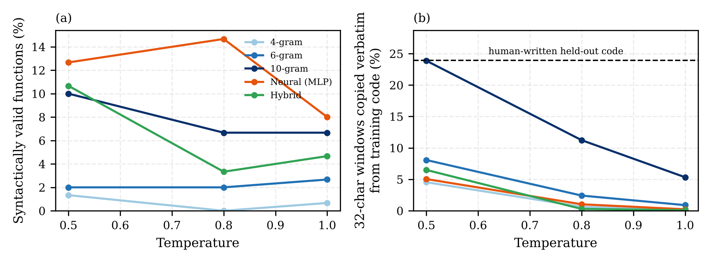
Fig. 5. Generated functions: (a) syntactic validity with respect to temperature; (b) percentage of windows of 32 characters that are copied exactly from the training set; the dotted line is the number of windows found in the held-out human text.
4.4 Generative Fuzz Testing (E4)
The results are compared in Table6I and Fig. 6 between the different fuzzers and whether the generator is generating the target's input language or not. On the Python unparser, only syntactically correct Python can access it; the language-aware strategies achieve 19.4% ± 3.6% and 17.1% ± 0.9% line coverage, respectively, while random characters achieve 12.0%. Random input is best (47.7% and 50.1%), since these two parsers are the novelty of characters that are unusual in their input language that are rewarded and which are most prone to triggering distinct behaviours (221 outcome signatures), but both are parsers for input languages that are different from Python. Coverage feedback showed a trade-off between coverage and validity. Rewarding unparser coverage increased the rate of usable generated inputs from 2.3% to 64.7% but reduced unparser coverage to 11.5%. It converged on a limited subset of the programs that are valid inputs into the small generator, by re-prompting with its own successful inputs. The same happened when we totalled feedback across all targets (12.0%). A language-competentgenerator is required, as well as a feedback loop, to preserve diversity, and mutation of actual code is a solid starting point for small generators, which is not bested by generative fuzzing.
TABLE 6: Fuzzing: final line coverage (%) after 1,500 inputs
Strategy | ast | tomllib | re._parser | Usable (%) | Behaviours
Random | 12.0 ± 0.8 | 47.7 ± 2.4 | 50.1 ± 1.4 | 5.8 | 221
Mutation | 19.4 ± 3.6 | 36.2 ± 7.6 | 37.9 ± 2.5 | 15.5 | 46
GenAI | 17.1 ± 0.9 | 38.1 ± 0.2 | 45.5 ± 1.4 | 2.3 | 58
GenAI + coverage | 12.0 ± 2.4 | 26.2 ± 3.0 | 47.9 ± 1.5 | 9.1 | 68
GenAI + AST feedback | 11.5 ± 2.4 | 25.5 ± 4.3 | 44.4 ± 2.5 | 64.7 | 43
Mean ± s.d. over five seeds; coverage relative to executable lines of each module. Usable: inputs with a parseable Python prefix. Behaviours: distinct outcome and exception signatures.

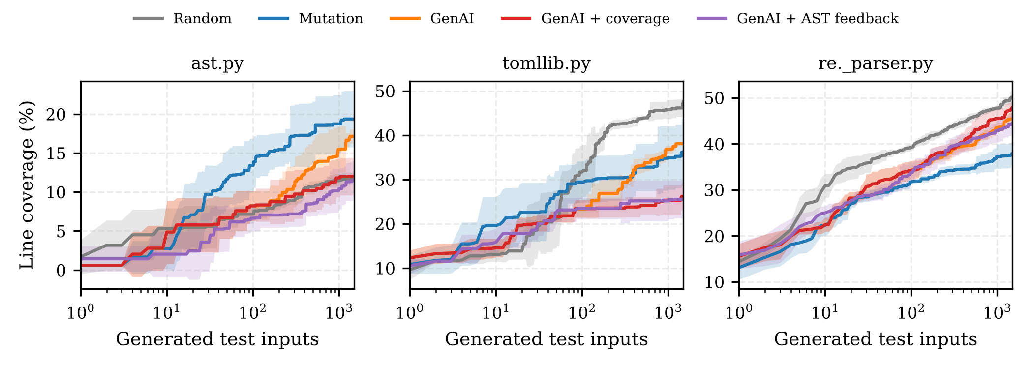
Fig. 6. Mean ± s.d. (over five seeds) line coverage of three pure-Python components for each generated input.
4.5 Developer Productivity (E5)
Fig. 7 and Table 7 show the productivity simulation. All models save keystrokes, with the saving being highest at an intermediate confidence threshold. The hybrid model saves up to 32.1% at τ = 0.3 (acceptance 37%), the neural model up to 29.7%, the 6-gram up to 31.3%, and the 4-gram up to 22.0%. As τ is raised, it becomes more likely to be accepted and also becomes more likely to be saved (11.8% at τ = 0.9); but increasing τ monotonically decreases the acceptance. These two goals are thus contradictory. A product tuned for a high acceptance rate (which shows a correlation with perceived productivity) loses out a lot of the possible effort saving, while a product tuned for the highest savings offers up more suggestions, of which most of the suggestions are rejected (31.0 suggestions per 100 characters at τ = 0.3 versus 6.6 at τ = 0.9). The cost of attention cannot be measured by the number of keystrokes, as suggested suggestions will be ignored, and the threshold should be determined in user studies .
TABLE 7: Keystroke simulation on held-out files
Model | τ | Saved (%) | Accepted (%) | Shown / 100 ch | Accepted len.
4-gram | 0.3 | 22.0 | 28.1 | 33.4 | 3.3
 | 0.6 | 16.3 | 54.5 | 18.2 | 2.6
 | 0.9 | 5.6 | 96.1 | 4.5 | 2.3
6-gram | 0.3 | 30.3 | 25.6 | 41.5 | 3.8
 | 0.6 | 28.5 | 56.4 | 22.9 | 3.2
 | 0.9 | 15.6 | 91.1 | 9.4 | 2.8
Neural (MLP) | 0.3 | 29.7 | 30.9 | 31.9 | 4.0
 | 0.6 | 26.9 | 60.6 | 16.5 | 3.7
 | 0.9 | 17.6 | 90.0 | 8.3 | 3.4
Hybrid | 0.3 | 32.1 | 37.2 | 31.0 | 3.8
 | 0.6 | 26.9 | 71.6 | 15.6 | 3.4
 | 0.9 | 11.8 | 97.4 | 6.6 | 2.8
42.2 k characters from 8 held-out files; a suggestion is the greedy completion to the end of the line, truncated where its joint probability falls below τ.

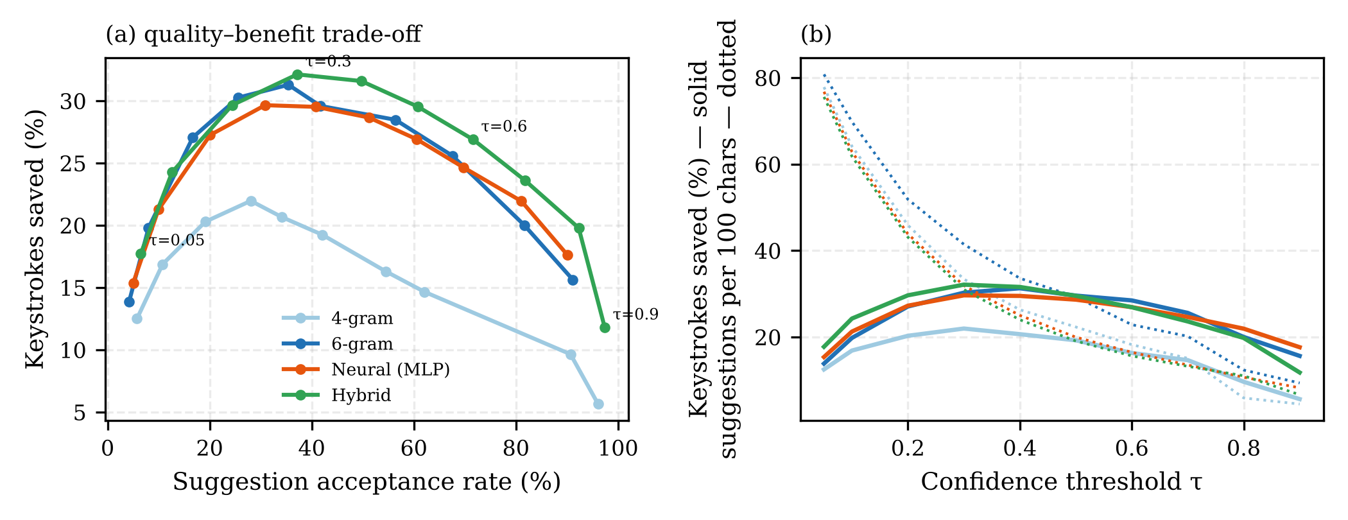
Fig. 7. Developer-productivity simulation of (a) keystroke savings and acceptance-rate, and (b) savings (solid) and suggestions presented/100 characters (dotted) versus the confidence-threshold, τ.
5. DISCUSSION
5.1 Implications for Practice
Generation quality is dependent on context and scale. Exact line completion changed from almost zero to around 1 in 10 lines by increasing the number of context characters from 5 to 64. The data scaling curve is steep, meaning larger models and corpora – as in industrial LLMs – are the source of capabilities.
- Don't pick models solely based on perplexity! The model that completed best had the worst cross-entropy. Code-generation systems should be evaluated based on downstream performance and executability [1] and [10].
- Sample, Verify and Select. Low Syntactic validity revealed that compile- and test-based gates are crucial, and likelihood-based selection and voting over several samples performed better than a single sample.
- Consider decoding as a compliance measure. Higher model capacity and lower temperature increased the number of verbatim copies. For deployments of large models, a combination of decoding policies, similarity filters and provenance tracking [7], [8] should be adopted.
- Use GenAI for testing where it fits – protect diversity. Language-aware generation only benefited when the target language matches the model's target language. The feedback that maximized input validity caused diversity and coverage to drop, while mutation of real code was a very good baseline.
Tune assistants towards the appropriate metric. There is a trade-off between acceptance rate and keystroke savings. The two should be monitored as well as costs and code quality.
5.2 Potential Bogus sources of Invalidity
Construct validity: exact match is not a strict proxy for usefulness, keystroke savings do not account for the effort that may be required for reading and checking the validity of the test, and line coverage is an incomplete measure of test adequacy. Internal validity: hyperparameters were not dependent on the current experiment; sampling-based results were averaged over 20 samples or over five experimental seeds; and the same syntax-error recovery routine was used for each of the strategies in the fuzzing harness. External validity: Models are orders of magnitude smaller than production LLMs, the corpus is a single language and codebase, and absolute numbers will vary with larger systems. The study's claims focus on mechanisms and trade-offs (context, selection, decoding, feedback alignment, threshold tuning) that are expected to transfer and not absolute performance.
5.3 Future Work
Natural extensions are subword-tokenized Transformer models, functional correctness via generated unit tests, security analysis of generated code, controlled user studies with keystroke data and perceived workload.
6. CONCLUSION
This paper offers a comprehensive, transparent, and reproducible study of generative AI in code generation, testing, and developer productivity. The possibility to train code models from scratch and apply them to real software allowed for the isolation of mechanisms which are typically concealed in proprietary systems. With longer contexts and mixtures of probabilistic and neural models, predictive quality increases, but generated text quality depends not only on perplexity, but also on the decoding and selection procedure. The lower the temperature, the more closely the training code is reproduced, and the larger the model is, the more so. Generative fuzzing faces two challenges: only targets that consume the language the generator can produce can be fuzzed, and feedback loops must balance input validity with diversity. Inline suggestions save up to 32% keystrokes with a tunable price in acceptance. The results and the Developed Code and Data support that these findings provide an empirical basis for responsibly engineering software development with the aid of GenAI.
REFERENCES
[1] M. Chen et al., “Evaluating large language models trained on code,” arXiv preprint arXiv:2107.03374, 2021. https://doi.org/10.48550/arXiv.2107.03374
[2] J. Austin et al., “Program synthesis with large language models,” arXiv preprint arXiv:2108.07732, 2021. https://doi.org/10.48550/arXiv.2108.07732
[3] A. Zia, C. Sharma, V. Giedt, and O. Ahmed, “Generating automated unit tests with LLMs: A practical solution to a key AI challenge,” reportedly IEEE Transactions on Software Engineering, vol. 50, no. 1, pp. 85–105, 2024. [Unverified—do not use without confirming the original publication.]
[4] S. Peng, E. Kalliamvakou, P. Cihon, and M. Demirer, “The impact of AI on developer productivity: Evidence from GitHub Copilot,” arXiv preprint arXiv:2302.06590, 2023. https://doi.org/10.48550/arXiv.2302.06590
[5] A. Fan et al., “Large language models for software engineering: Survey and open problems,” in Proc. 2023 IEEE/ACM International Conference on Software Engineering: Future of Software Engineering (ICSE-FoSE), 2023, pp. 31–53. https://doi.org/10.1109/ICSE-FoSE59343.2023.00008
[6] X. Hou et al., “Large language models for software engineering: A systematic literature review,” ACM Transactions on Software Engineering and Methodology, vol. 33, no. 8, Art. no. 220, pp. 1–79, 2024. https://doi.org/10.1145/3695988
[7] N. Carlini et al., “Extracting training data from large language models,” in Proc. 30th USENIX Security Symposium (USENIX Security), 2021, pp. 2633–2650.
[8] N. Carlini, D. Ippolito, M. Jagielski, K. Lee, F. Tramèr, and C. Zhang, “Quantifying memorization across neural language models,” in Proc. International Conference on Learning Representations (ICLR), 2023.
[9] H. Pearce, B. Ahmad, B. Tan, B. Dolan-Gavitt, and R. Karri, “Asleep at the keyboard? Assessing the security of GitHub Copilot’s code contributions,” in Proc. 2022 IEEE Symposium on Security and Privacy (SP), 2022, pp. 754–768. https://doi.org/10.1109/SP46214.2022.9833571
[10] J. Liu, C. S. Xia, Y. Wang, and L. Zhang, “Is your code generated by ChatGPT really correct? Rigorous evaluation of large language models for code generation,” in Advances in Neural Information Processing Systems (NeurIPS), vol. 36, 2023. https://arxiv.org/abs/2305.01210
[11] A. Hindle, E. T. Barr, M. Gabel, Z. Su, and P. Devanbu, “On the naturalness of software,” in Proc. 34th International Conference on Software Engineering (ICSE), 2012, pp. 837–847. https://doi.org/10.1109/ICSE.2012.6227135
[12] M. Bruch, M. Monperrus, and M. Mezini, “Learning from examples to improve code completion systems,” in Proc. 7th Joint Meeting of the European Software Engineering Conference and ACM SIGSOFT Symposium on the Foundations of Software Engineering (ESEC/FSE), 2009, pp. 213–222. https://doi.org/10.1145/1595696.1595728
[13] V. Raychev, M. Vechev, and E. Yahav, “Code completion with statistical language models,” in Proc. 35th ACM SIGPLAN Conference on Programming Language Design and Implementation (PLDI), 2014, pp. 419–428. https://doi.org/10.1145/2594291.2594321
[14] M. Allamanis, E. T. Barr, P. Devanbu, and C. Sutton, “A survey of machine learning for big code and naturalness,” ACM Computing Surveys, vol. 51, no. 4, Art. no. 81, pp. 1–37, 2018. https://doi.org/10.1145/3212695
[15] Y. Bengio, R. Ducharme, P. Vincent, and C. Janvin, “A neural probabilistic language model,” Journal of Machine Learning Research, vol. 3, pp. 1137–1155, 2003.
[16] A. Vaswani et al., “Attention is all you need,” in Advances in Neural Information Processing Systems (NeurIPS), vol. 30, pp. 5998–6008, 2017.
[17] Y. Li et al., “Competition-level code generation with AlphaCode,” Science, vol. 378, no. 6624, pp. 1092–1097, 2022. https://doi.org/10.1126/science.abq1158
[18] A. Holtzman, J. Buys, L. Du, M. Forbes, and Y. Choi, “The curious case of neural text degeneration,” in Proc. International Conference on Learning Representations (ICLR), 2020. https://arxiv.org/abs/1904.09751
[19] B. P. Miller, L. Fredriksen, and B. So, “An empirical study of the reliability of UNIX utilities,” Communications of the ACM, vol. 33, no. 12, pp. 32–44, 1990. https://doi.org/10.1145/96267.96279
[20] V. J. M. Manès et al., “The art, science, and engineering of fuzzing: A survey,” IEEE Transactions on Software Engineering, vol. 47, no. 11, pp. 2312–2331, 2021. https://doi.org/10.1109/TSE.2019.2946563
[21] P. Godefroid, H. Peleg, and R. Singh, “Learn&Fuzz: Machine learning for input fuzzing,” in Proc. 32nd IEEE/ACM International Conference on Automated Software Engineering (ASE), 2017, pp. 50–59. https://doi.org/10.1109/ASE.2017.8115618
[22] C. Lemieux, J. P. Inala, S. K. Lahiri, and S. Sen, “CodaMosa: Escaping coverage plateaus in test generation with pre-trained large language models,” in Proc. 45th IEEE/ACM International Conference on Software Engineering (ICSE), 2023, pp. 919–931. https://doi.org/10.1109/ICSE48619.2023.00085
[23] Z. Yuan et al., “No more manual tests? Evaluating and improving ChatGPT for unit test generation,” arXiv preprint arXiv:2305.04207, 2023. https://doi.org/10.48550/arXiv.2305.04207
[24] Y. Deng, C. S. Xia, H. Peng, C. Yang, and L. Zhang, “Large language models are zero-shot fuzzers: Fuzzing deep-learning libraries via large language models,” in Proc. 32nd ACM SIGSOFT International Symposium on Software Testing and Analysis (ISSTA), 2023, pp. 423–435. https://doi.org/10.1145/3597926.3598067
[25] C. S. Xia, M. Paltenghi, J. L. Tian, M. Pradel, and L. Zhang, “Fuzz4All: Universal fuzzing with large language models,” in Proc. 46th IEEE/ACM International Conference on Software Engineering (ICSE), 2024. https://arxiv.org/abs/2308.04748
[26] A. Ziegler et al., “Productivity assessment of neural code completion,” in Proc. 6th ACM SIGPLAN International Symposium on Machine Programming (MAPS), 2022, pp. 21–29. https://arxiv.org/abs/2205.06537
[27] S. Barke, M. B. James, and N. Polikarpova, “Grounded Copilot: How programmers interact with code-generating models,” Proceedings of the ACM on Programming Languages, vol. 7, no. OOPSLA1, Art. no. 78, pp. 85–111, 2023. https://doi.org/10.1145/3586030
[28] N. Perry, M. Srivastava, D. Kumar, and D. Boneh, “Do users write more insecure code with AI assistants?,” in Proc. 2023 ACM SIGSAC Conference on Computer and Communications Security (CCS), 2023, pp. 2785–2799. https://doi.org/10.1145/3576915.3623157
[29] I. H. Witten and T. Bell, “The zero-frequency problem: Estimating the probabilities of novel events in adaptive text compression,” IEEE Transactions on Information Theory, vol. 37, no. 4, pp. 1085–1094, 1991. https://doi.org/10.1109/18.87000
[30] S. F. Chen and J. Goodman, “An empirical study of smoothing techniques for language modeling,” Computer Speech & Language, vol. 13, no. 4, pp. 359–394, 1999. https://doi.org/10.1006/csla.1999.0128

