Journal of Integrated Scientific Research (JISR)

https://jisrjournal.com/

A Study of Self-Medication Practices and Antibiotic Misuse Among Urban and Rural Populations in India
Kunal Gulati¹, Dr. Sneha Khadse²
¹Assistant Professor, Department of Management,
Sumandeep Vidyapeeth Deemed to be University, Vadodara, Gujarat
²Independent Researcher, Nirwan University, Jaipur, Rajasthan, India
kunalgulati003@gmail.com
Abstract

Antimicrobial resistance is emerging as a problem in Indian society due to self-medication with antibiotics; however, there is a lack of direct urban–rural comparative studies. This study aimed to find out how the prevalence, patterns and predictors of self-medication and misuse of antibiotics are different between urban and rural adult populations. The present study was conducted through multi-stage random sampling, and it was a community-based comparative cross-sectional study which included 800 adults (400 rural and 400 urban) from one district of Maharashtra. Self-medication in the last 3 months, antibiotic use and behaviours, and antibiotic knowledge were collected in a questionnaire administered to the children by an interviewer, which was pre-tested. Chi-Square tests and Multivariable Logistic regression: Results: Self-medication was reported by 56.6% (95% CI 53.2–60.0) of participants, more in urban than rural areas (64.2% vs 49.0%; p < 0.001). There was no difference in antibiotic self-medication (22.2% vs 23.0%); however, rural self-medicators were more likely to take an antibiotic (46.9% vs 34.6%, P value= 0.008). Amoxicillin and azithromycin were most commonly used, with 57.5% of episodes being prescribed in the WHO Watch-group class of drugs. Testing for rural antibiotics revealed that 30.4% of these were supplied by informal providers. Rural users more often did not complete the course (79.3% vs 60.7%) or know the dose (56.5% vs 32.6%). The distance to the doctor was also an independent predictor of self-medication with antibiotics (AOR 1.74; 95% CI 1.16–2.60) when living more than 5 km from a doctor. Conclusion: Although overall about 1 in 4 adults do this, those who do take antibiotics without a prescription do so less safely in rural areas, as a result of lower levels of doctor access. Strategies to reduce the availability of antibiotics that do not require a prescription need to be given greater importance, as well as ensuring qualified prescription sales are strong in rural areas.

Keywords: self-medication, antibiotic misuse, antimicrobial resistance, urban-rural, India and community survey.
- Introduction
Self-medication is taking medicines without the advice of a competent prescriber for the treatment of self-diagnosed symptoms. While the World Health Organization (WHO) recognizes responsible use of a safe product by itself (self-care) from over-the-counter (OTC) dispensaries, the same occurs for self-medication with prescription-only medicines (POMs), particularly antibiotics, which is recognized as a leading driver of antimicrobial resistance (AMR) [9]. Inappropriate use of antibiotics is a serious public health problem which will lead to increased antimicrobial resistance and decreased effectiveness of treatment. Developing resistant organisms can result from self-medication, wrong dosage, and random antibiotic administration. Thus, responsible use of antibiotics and antimicrobial stewardship and surveillance are highlighted by Mounya et al. (2025) [13]. India has one of the highest burdens of AMR in the world. AMR directly caused approximately 297,000 deaths in India in 2019, and approximately 1.04 million deaths are estimated to be due to drug-resistant infections [1, 2]. Resistance is highest when most readily purchased drugs are involved; here, the third-generation cephalosporins and fluoroquinolones are the most readily bought drugs [3]. There is a great scale of non-prescribed use. A pooled estimate of mean prevalence of self-medication from 17 Indian studies (involving 10,248 population) was 53.6%, with a range of prevalence between 8.3% and 92%. Another meta-analysis of 17 studies involving 7,847 children estimated that 19.8% of Indian children were self-medicating with antibiotics, with the highest prevalence (30.7%) in the northern region of the country [5]. This is echoed by the supply side. India used 5,071 million defined daily doses (DDDs) of antibiotics (in 2019, 10.4 DDD/1,000 people/day) compared with 4,298 million DDDs in 2015 (7.5 DDD/1,000 people/day) according to an assessment of country consumption of antibiotics in the private sector. In addition, 47.1% of these DDDs were centrally unapproved formulations with the most used being azithromycin 500 mg (7.6%) and cefixime 200 mg (6.5%) [6]. It is estimated that an uptake of 85-90% of antibiotics happens in the private sector in India [6]. The differences in the practice of both urban and rural India are inconclusive. Some studies found higher misuse of antibiotics in rural areas, as formal providers (doctors) are replaced by informal providers such as chemists and community members; for example, [7] reported antibiotic use by self-medication in 51.5% of urban and 7.7% of rural consumers in a community study in western Maharashtra. There is a lack of direct urban–rural comparison in most studies of Indians, as they are cross-sectional studies of a single setting or they sample a single student population. Thus, this study was designed to (1) to estimate the prevalence of general and antibiotic self-medication status among adults in matched urban and rural populations, (2) to describe the sources, indications and specific antibiotics involved, (3) assess antibiotic knowledge and misuse behaviour status and (4) to identify the independent predictors determining antibiotic self-medication status.

2. Materials and Methods

2.1 Study design and setting
A comparative cross-sectional study was conducted in two climatic zones, one urban municipal and the other neighbouring rural villages of the same district, Maharashtra, India, for a 3-month period in the community. The urban and rural sites were selected from the same district to ensure commonalities in drug regulation and access to the state health system.
2.2 Sample size
Sample Size was determined to identify a difference between the two independent proportions of people who self-medicate with antibiotics. The minimum was 358 per group, with a prevalence of 20% in one group, and 29% in the other, 80% power and two-sided α = 0.05:
n = [Z_{1−α/2} √(2p̄q̄) + Z_{1−β} √(p₁q₁ + p₂q₂)]² / (p₁ − p₂)²
Allowing 10% non-response, 400 adults were enrolled from each setting (total n = 800).

2.3 Sampling
A two-stage random sampling technique was implemented. The 10 wards were picked by simple random sampling method in the urban area, and 40 households were chosen in each of the wards using systematic random sampling method from the voter's register. For the rural block a probabilistic sample of 10 villages and a systematic sample of 40 households per village (with a random starting household) were selected. Kish grid was used for the selection of one adult per household.
For inclusion, the following criteria were considered: age ≥ 18 years; living in the region for ≥6 months; being able to provide informed consent. Exclusion criteria: qualified health professionals and pharmacists; individuals with low cognition/con cognitively impaired at the time of the visit; and severely ill persons.
2.4 Study tool
To collect the data, an interviewer-administered, pre-tested semi-structured questionnaire in Marathi, Hindi or English (Appendix) was used. This instrument was divided into four sections: sociodemographic information; use of self-medication in the last 3 months (drugs, symptoms, sources and reasons for taking drugs); antibiotic use in the last 3 months, how the antibiotics were selected (by their name or drug packaging or by the physician's order) and habits around antibiotic use; and 8 knowledge items about antibiotics and resistance in the form of true/false statements. Three experts in the fields of community medicine and pharmacology checked the content of the article for validity. Thirty adults outside the study area were given a pre-test, and a Cronbach's α for the knowledge scale was found to be 0.78, with pre-test data not being included in the analysis.
2.5 Operational definitions
Self-medication: taking (anyedleco) any allopathic medicine in the last three months without that visit from registered medical practitioner for that episode.
- Antibiotic self-medication (ASM): Taking a systemic antibacterial agent for the same indication(s) with the same prescription or the use of leftover tablets.
- Adequate knowledge: ATM transaction: =< 3 yes answers, out of 8 yes answers, confidence: =< 2.
2.6 Statistical analysis
Data input was carried out using Microsoft®, Excel and analysis was done in Python 3 (pandas, SciPy). For categorical variables, means and percentages were presented and compared between urban and rural participants using the chi-square test. 95% Wilson confidence intervals are obtained for the prevalence of an illness. All the sociodemographic, access and knowledge variables initially selected were included in a multivariable binary logistic regression with ASM as the outcome. Results presented are adjusted odds ratios (AOR) and 95% confidence intervals (CI). The Hosmer–Lemeshow test was performed to test the model fit, and the variance inflation factor (all VIFs<2.5) was calculated to test multicollinearity; p<0.05 was considered significant.
2.7 Ethics
The study was approved by the Institutional Ethics Committee. Informed written consent was obtained from all the participants (thumb impression was taken with an impartial witness where there was no ability to write). Advice was presented verbally, and the information leaflet was given to participants who reported unsafe antibiotic use.
3. Results
3.1 Participant characteristics
All 800 adult enrolments went through the interview (400 urban and 400 rural). As seen in Table 1, rural participants were less educated, had lower earnings, less health insurance and a larger percentage (57.8%) lived more than 5km away from a physician as compared to urban participants (11.5%).
Table 1. Sociodemographic characteristics of participants by residence (n = 800)
Characteristic | Urban, n (%) (n = 400) | Rural, n (%) (n = 400) | χ² | p
Sex |  |  | 3.92 | 0.048
Male | 214 (53.5) | 186 (46.5)
Female | 186 (46.5) | 214 (53.5)
Age (years) |  |  | 6.43 | 0.092
18–29 | 120 (30.0) | 97 (24.2)
30–44 | 128 (32.0) | 120 (30.0)
45–59 | 93 (23.2) | 121 (30.2)
60 and above | 59 (14.8) | 62 (15.5)
Education |  |  | 119.16 | <0.001
None / primary | 47 (11.8) | 155 (38.8)
Secondary | 175 (43.8) | 187 (46.8)
Graduate and above | 178 (44.5) | 58 (14.5)
Socioeconomic class (modified Kuppuswamy) |  |  | 58.62 | <0.001
Low | 102 (25.5) | 205 (51.2)
Middle | 193 (48.2) | 140 (35.0)
High | 105 (26.2) | 55 (13.8)
Health insurance | 195 (48.8) | 117 (29.2) | 31.97 | <0.001
Doctor more than 5 km away | 46 (11.5) | 231 (57.8) | 189.00 | <0.001

3.2 Prevalence of self-medication
Overall, 453 of 800 participants (56.6%; 95% CI 53.2–60.0) had self-medicated in the past three months, and 181 (22.6%; 95% CI 19.9–25.7) had self-medicated with an antibiotic. General self-medication was more common in urban areas (64.2% vs 49.0%; χ² = 18.94, p < 0.001). There was no difference in antibiotic self-medication between the two settings (22.2% vs 23.0%, p = 0.80, Figure 1).
The settings varied in terms of the people self-medicating. Among self-medicators, rural participants were more likely to use an antibiotic: 92 of 196 (46.9%) rural against 89 of 257 (34.6%) urban self-medicators (χ² = 7.02, p = 0.008).
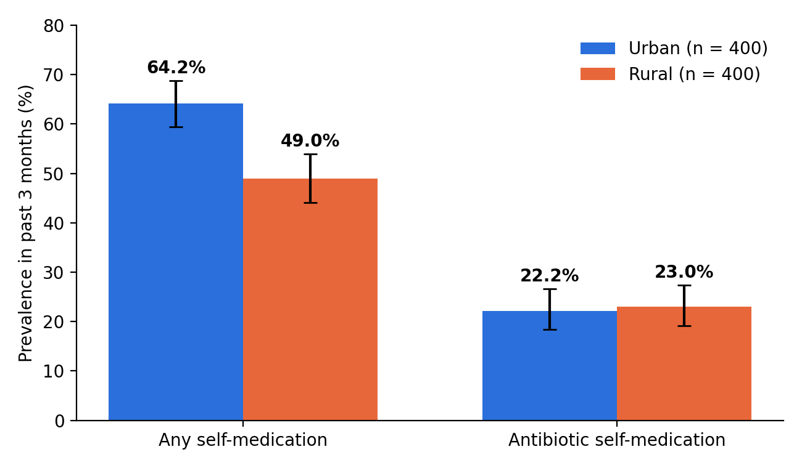
Figure 1. Prevalence of self-medication and antibiotic self-medication by residence. Error bars show 95% confidence intervals.

3.3 Antibiotics used, indications and sources
Table 2 shows that the most commonly used antibiotics were azithromycin (28.2%), amoxicillin (with/without claviculanic acid) (28.7%), fluoroquinolones (14.9%), and cefixime (14.4%). More than half (57.5%) of all antibiotic episodes were for the use of WHO Watch-group drugs (azithromycin, cefixime, any of the fluoroquinolones). Cold, cough or sore throat (35.4%) was the most prevalent indication for taking an antibiotic—the vast majority of these are of viral origin.
Table 2. Antibiotics used and indications among antibiotic self-medicators (n = 181)
Variable | Urban, n (%) (n = 89) | Rural, n (%) (n = 92) | Total, n (%) (n = 181)
Antibiotic (WHO AWaRe group)
Amoxicillin ± clavulanate (Access) | 24 (27.0) | 28 (30.4) | 52 (28.7)
Azithromycin (Watch) | 30 (33.7) | 21 (22.8) | 51 (28.2)
Ciprofloxacin / ofloxacin (Watch) | 13 (14.6) | 14 (15.2) | 27 (14.9)
Cefixime (Watch) | 13 (14.6) | 13 (14.1) | 26 (14.4)
Metronidazole (Access) | 5 (5.6) | 10 (10.9) | 15 (8.3)
Doxycycline (Access) | 4 (4.5) | 6 (6.5) | 10 (5.5)
Indication
Cold, cough or sore throat | 36 (40.4) | 28 (30.4) | 64 (35.4)
Fever | 20 (22.5) | 27 (29.3) | 47 (26.0)
Diarrhoea | 17 (19.1) | 23 (25.0) | 40 (22.1)
Urinary symptoms | 6 (6.7) | 8 (8.7) | 14 (7.7)
Toothache | 7 (7.9) | 4 (4.3) | 11 (6.1)
Skin infection | 3 (3.4) | 2 (2.2) | 5 (2.8)

Pharmacies selling without a prescription were the main source in both settings (Figure 2). Informal providers supplied 30.4% of rural antibiotic users but only 4.5% of urban users, while urban users more often reused an old prescription (22.5% vs 13.0%).
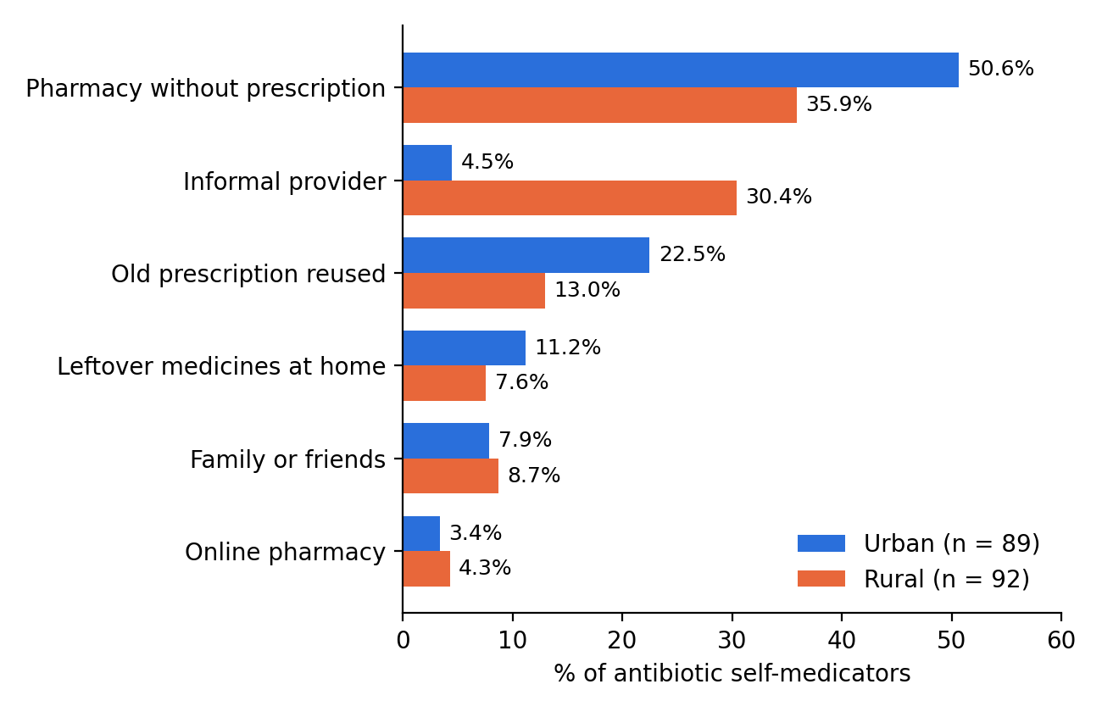
Figure 2. Main source of antibiotics among antibiotic self-medicators, by residence.

3.4 Antibiotic misuse behaviours
Unsafe practices were common in both groups and more frequent among rural users (Figure 3). Rural users more often failed to complete a five-day course (79.3% vs 60.7%; p = 0.006), did not know the correct dose (56.5% vs 32.6%; p = 0.001) and shared antibiotics with family (34.8% vs 18.0%; p = 0.011).
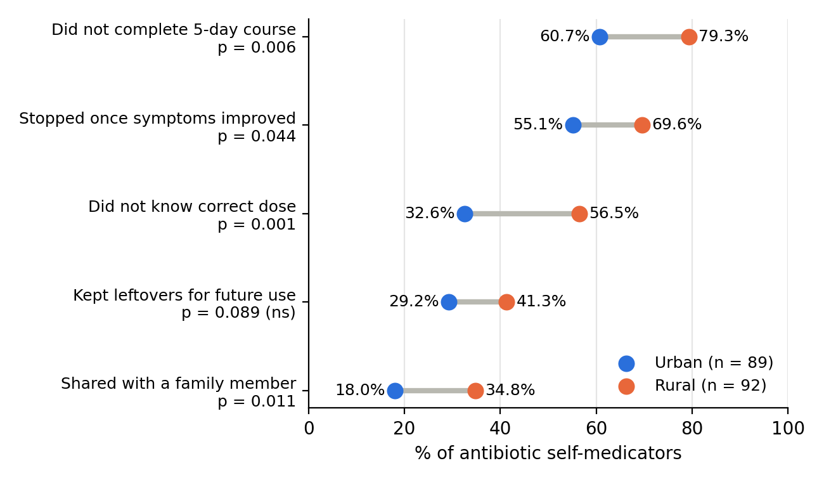
Figure 3. Antibiotic misuse behaviours among antibiotic self-medicators, by residence (chi-square p-values; ns, not significant).

3.5 Knowledge of antibiotics and resistance
The mean knowledge score was 5.62 (SD 1.43) out of 8 in urban and 4.03 (SD 1.46) in rural participants (t = 15.50, p < 0.001). Adequate knowledge was found in 78.0% of urban and 36.5% of rural participants. The weakest item in both groups was the belief that antibiotics cure colds: only 51.0% of urban and 26.2% of rural participants answered it correctly (Table 3).
Table 3. Correct Responses to Antibiotic Knowledge Items By Residence
Statement (correct answer) | Urban, n (%) | Rural, n (%) | p
Antibiotics cure viral infections such as the common cold (False) | 204 (51.0) | 105 (26.2) | <0.001
Antibiotics should be stopped once you feel better (False) | 234 (58.5) | 154 (38.5) | <0.001
Misuse of antibiotics can make them stop working (True) | 309 (77.2) | 257 (64.2) | <0.001
Antibiotic resistance can spread between people (True) | 296 (74.0) | 183 (45.8) | <0.001
Antibiotics kill bacteria (True) | 308 (77.0) | 243 (60.8) | <0.001
Antibiotics can cause side effects such as diarrhoea (True) | 299 (74.8) | 203 (50.8) | <0.001
It is safe to take antibiotics left over by a family member (False) | 271 (67.8) | 196 (49.0) | <0.001
Taking more antibiotic makes recovery faster (False) | 294 (73.5) | 232 (58.0) | <0.001
Adequate knowledge (score ≥ 5 of 8) | 312 (78.0) | 146 (36.5) | <0.001

3.6 Factors associated with antibiotic self-medication
Being more than 5 km away from doctors was the most significant independent predictor for antibiotic self-medication (AOR= 1.74; 95% CI= 1.16–2.60; p=0.008) in the multivariable model. Even after adjusting for distance and other factors, residence in rural areas was a risk factor for use of antibiotics (AOR 0.62; 95% CI 0.39–0.98), suggesting that many of the differences in antibiotic use by self-medicators result from less ready access to doctors in rural areas. Only low education and age 30-44 were significantly associated in bivariate association. The model fitted well (Hosmer–Lemeshow χ² = 5.31, df = 8, p = 0.72; all VIF < 2.0).
Table 4. Crude and adjusted odds ratios for antibiotic self-medication (n = 800)
Variable (reference) | COR (95% CI) | p | AOR (95% CI) | p
Rural residence (urban) | 1.04 (0.75–1.45) | 0.800 | 0.62 (0.39–0.98) | 0.039
Male (female) | 0.88 (0.63–1.23) | 0.447 | 0.87 (0.62–1.22) | 0.426
Age 30–44 (18–29) | 1.47 (1.04–2.08) | 0.030 | 1.47 (0.95–2.28) | 0.084
Age 45–59 (18–29) | 0.79 (0.53–1.16) | 0.221 | 0.95 (0.58–1.53) | 0.822
Age 60+ (18–29) | 0.93 (0.58–1.48) | 0.746 | 1.10 (0.63–1.91) | 0.740
Secondary education (graduate+) | 0.84 (0.60–1.18) | 0.317 | 1.03 (0.67–1.59) | 0.885
None/primary education (graduate+) | 1.45 (1.01–2.09) | 0.046 | 1.43 (0.86–2.38) | 0.170
Middle SES (high) | 0.78 (0.55–1.10) | 0.153 | 0.86 (0.54–1.37) | 0.516
Low SES (high) | 1.29 (0.92–1.81) | 0.138 | 1.18 (0.73–1.90) | 0.505
Health insurance (none) | 0.87 (0.62–1.23) | 0.427 | 0.89 (0.63–1.28) | 0.541
Doctor more than 5 km away (≤ 5 km) | 1.51 (1.07–2.11) | 0.018 | 1.74 (1.16–2.60) | 0.008
Inadequate knowledge (adequate) | 1.25 (0.89–1.74) | 0.193 | 1.18 (0.80–1.75) | 0.396

COR, crude odds ratio; AOR, adjusted odds ratio; SES, socioeconomic status. Age and sex were kept in the model as a priori confounders.

4. Discussion

Results of this study revealed that over half of adults self-medicated within three months, and almost a quarter did self-medicate with an antibiotic. It was not so much the extent of antibiotic self-medication, as the nature and way it was taking place, that constituted the principal urban – rural contrast. Overall, the data showed that urban residents self-medicated more frequently than all other groups, but rural selfmedicators were more inclined to take an antibiotic, and to use an informal provider or to use it unsafely. Prevalence. The overall prevalence of self-medication (56.6%) is comparable to the pooled estimate of India (53.6%) [4] and is similar to those reported in the country, which range between 20% and 75%. The urban prevalence is higher, as corroborated by the western Maharashtra study, which reported self-medication as more of an urban phenomenon (51.5% in urban and 7.7% in rural areas) [7]; however, the urban–rural differences here are smaller than what was reported in the latter. OTC self-care is perhaps more easily achieved in cities, given greater concentration of pharmacies, more purchasing power and increased brand awareness.

The prevalence of self-medication with antibiotics is 22.6%, which is similar to the pooled estimate of Indian children (19.8%) [5]. The fact that it didn't vary by where they lived, but the proportion that was self-administered through antibiotics was higher in villages (46.9% vs 34.6%), is significant. This translates to saying that tabulations of generalized self-medication only would be misleading and also indicate lower risks in rural populations. What antibiotic(s) and for what? The most frequently used antibiotic was azithromycin, which was consistent with the national picture where, in 2019, azithromycin 500 mg was the most sold antibiotic formulation [6]. Over half of episodes were associated with WHO Watch group drugs that have a higher associated risk of resistance [8].

The majority of courses, nearly one third, were for cold, cough or sore throat; and approximately three-quarters of all people living in rural areas had no knowledge that antibiotics can't cure a cold. The misconception could eradicate much of the unnecessary use. Access as the driver. Distance to a doctor was the only independent factor associated with self-medication with antibiotics: AOR 1.74. After adjustment for distance, rural residence per se was not a risk factor. This indicates that access rather than rural culture is the more important factor. The informal provider is the first contact for healthcare; at least 30.4% of the antibiotics supplied in rural communities are from informal providers due to the lack of a doctor in the vicinity. Residence was strongly associated with knowledge, and knowledge was not an independent predictor, implying behaviour will not change without access to the skills of skilled birth attendance, even when the nearest doctor is very distant. Misuse behaviours.

The use of incomplete courses, as well as the uncertainty regarding the dose and sharing of antibiotics, was all significantly more prevalent among rural users. These behaviours allow bacteria to be exposed to sub-therapeutic doses of the medication and are a direct path to resistance. They also indicate where the Schedule H / H1 guidelines are poorly followed, as that is where the loose strips of tablets without counselling are sold. Implications. Three “priorities in practice” ensue. One is strict enforcement of the sale of antibiotics only on prescription in the pharmacies, with Schedule H1 registers being maintained and subjected to audit. Second is to close the access gap with the help of Ayushman Arogya Mandirs (health and wellness centres) and teleconsultation so that the patient can see a qualified prescriber without travelling to the villages. Thirdly, involve informal providers and pharmacists, who should receive brief training in the case above, as well as public awareness campaigns, on cases in which antibiotics are not required.

5. Strengths and Limitations

The random selection of participants from the community, having similar numbers of urban and rural dwellers in the same district, obtaining details about drug identification from packaging or show cards, and assembling a multivariable model whereby access is distinct from residence were the strengths of the study. It also comes with its downsides. The cross-sectional design illustrates relationships and is not causal. A three-month time frame could underestimate reporting, and there could be social desirability bias that underestimates the reporting of unsafe behaviours. The findings are based on one district in the state of Maharashtra, and may not be relevant to other states with different health systems. Sometimes the antibiotics were dispensed as loose tablets by informal providers, and so a few drug names might have been miscategorised. Clinical outcome of each episode and resistance in participants were not measured.

6. Conclusion and Recommendations

Self-medication is prevalent in both urban and rural India, and approximately one-fourth of the adults in India self-medicate with antibiotics irrespective of urban or rural environment. Access distance and misuse of antibiotics were the most significant independent factors, as well as increased likelihood of using antibiotics and acquiring them from informal providers among rural self-medicators. But improving the availability of qualified antibiotic prescribers in rural areas is as important to reduce the misuses of antibiotics as learning about it as a public.

Regulation: implement Schedule H1 in pharmacy, and penalise sale of antibiotic without prescription in the sale register for non-prescription sale.

Access: increase the access for Tele Consultation and staffed Ayushman Arogya Mandirs in remote villages (more than 5 km away from doctors).

Frontline providers: educate and orientate the pharmacists and informal providers on viral illness and on distributing the 100% of viral illness Course + Dosing Advice.

Public messaging: speak in local languages to those in rural areas that antibiotics are not a cure for colds, through ASHA workers.

Research: perform this study in multiple states and tie self-medication with resistance surveillance of communities.

References
- Antimicrobial Resistance Collaborators. (2022). Global burden of bacterial antimicrobial resistance in 2019: A systematic analysis. The Lancet, 399(10325), 629–655. https://doi.org/10.1016/S0140-6736(21)02724-0
- Bert, F., Previti, C., Calabrese, F., Scaioli, G., & Siliquini, R. (2022). Antibiotic self-medication among children: A systematic review. Antibiotics, 11(11), Article 1583. https://doi.org/10.3390/antibiotics11111583
- Das, J., Holla, A., Mohpal, A., & Muralidharan, K. (2016). Quality and accountability in health care delivery: Audit-study evidence from primary care in India. American Economic Review, 106(12), 3765–3799. https://doi.org/10.1257/aer.20151138
- GBD 2021 Antimicrobial Resistance Collaborators. (2024). Global burden of bacterial antimicrobial resistance 1990–2021: A systematic analysis with forecasts to 2050. The Lancet, 404(10459), 1199–1226. https://doi.org/10.1016/S0140-6736(24)01867-1
- Institute for Health Metrics and Evaluation. (2023). The burden of antimicrobial resistance (AMR) in India [Fact sheet]. IHME. https://www.healthdata.org/
- Klein, E. Y., Van Boeckel, T. P., Martinez, E. M., Pant, S., Gandra, S., Levin, S. A., Goossens, H., & Laxminarayan, R. (2018). Global increase and geographic convergence in antibiotic consumption between 2000 and 2015. Proceedings of the National Academy of Sciences, 115(15), E3463–E3470. https://doi.org/10.1073/pnas.1717295115
- Kotwani, A., & Holloway, K. (2011). Trends in antibiotic use among outpatients in New Delhi, India. BMC Infectious Diseases, 11, Article 99. https://doi.org/10.1186/1471-2334-11-99
- Koya, S. F., Ganesh, S., Selvaraj, S., Wirtz, V. J., Galea, S., & Rockers, P. C. (2022). Consumption of systemic antibiotics in India in 2019. The Lancet Regional Health – Southeast Asia, 4, Article 100025. https://doi.org/10.1016/j.lansea.2022.100025
- Laxminarayan, R., Duse, A., Wattal, C., Zaidi, A. K. M., Wertheim, H. F. L., Sumpradit, N., Vlieghe, E., Hara, G. L., Gould, I. M., Goossens, H., Greko, C., So, A. D., Bigdeli, M., Tomson, G., Woodhouse, W., Ombaka, E., Peralta, A. Q., Qamar, F. N., Mir, F., … Cars, O. (2013). Antibiotic resistance—the need for global solutions. The Lancet Infectious Diseases, 13(12), 1057–1098. https://doi.org/10.1016/S1473-3099(13)70318-9
- Limaye, D., Limaye, V., Fortwengel, G., & Krause, G. (2018). Self-medication practices in urban and rural areas of western India: A cross sectional study. International Journal of Community Medicine and Public Health, 5(7), 2672–2685. https://www.ijcmph.com/index.php/ijcmph/article/view/3266 [verify volume and pages]
- Ministry of Health and Family Welfare. (2017). National action plan on antimicrobial resistance (NAP-AMR) 2017–2021. Government of India.
- Morgan, D. J., Okeke, I. N., Laxminarayan, R., Perencevich, E. N., & Weisenberg, S. (2011). Non-prescription antimicrobial use worldwide: A systematic review. The Lancet Infectious Diseases, 11(9), 692–701. https://doi.org/10.1016/S1473-3099(11)70054-8
- Mounya, K. S., Kumaravel, S., Arora, A., & Khadse, S. (2025). Antimicrobial resistance: Mechanisms, trends, and future directions. International Journal of Integrative Studies, 1(3), 10–31.
- Nepal, G., & Bhatta, S. (2018). Self-medication with antibiotics in WHO Southeast Asian Region: A systematic review. Cureus, 10(4), Article e2428. https://doi.org/10.7759/cureus.2428
- Ocan, M., Obuku, E. A., Bwanga, F., Akena, D., Richard, S., Ogwal-Okeng, J., & Obua, C. (2015). Household antimicrobial self-medication: A systematic review and meta-analysis of the burden, risk factors and outcomes in developing countries. BMC Public Health, 15, Article 742. https://doi.org/10.1186/s12889-015-2109-3
- Rashid, M., Chhabra, M., Kashyap, A., Undela, K., & Gudi, S. K. (2020). Prevalence and predictors of self-medication practices in India: A systematic literature review and meta-analysis. Current Clinical Pharmacology, 15(2), 90–101. https://pmc.ncbi.nlm.nih.gov/articles/PMC7579319
- Selvaraj, K., Kumar, S. G., & Ramalingam, A. (2014). Prevalence of self-medication practices and its associated factors in urban Puducherry, India. Perspectives in Clinical Research, 5(1), 32–36. https://doi.org/10.4103/2229-3485.124569
- World Health Organization. (2000). Guidelines for the regulatory assessment of medicinal products for use in self-medication. WHO.
- World Health Organization. (2022). The WHO AWaRe (Access, Watch, Reserve) antibiotic book. WHO.

